**Online Shopping For Saravanas Textiles**

B.Sc. (Special) in Computing & Information Systems

Department of Computing & Information Systems

Faculty of Applied Sciences

Sabaragamuwa University of Sri Lanka

September 2016

# 

# 

Web Based Online Shopping System

S.Sivathmeega

EP 1585

12/AS/CI/086

Report submitted for the Mini project for B.Sc. (Special) in Computing & Information Systems

Department of Computing & Information Systems

Faculty of Applied Sciences

Sabaragamuwa University of Sri Lanka

September 2016

# Certificate of Approval

I hereby declare that this report is from students’ own work and effort, and all other sources of information used have been acknowledged. This report has been submitted with my approval.

................................ ................................

Name of Supervisor Signature of supervisor

................................ Date

# Declaration

I hereby declare that the project work entitled Web based Online Shopping System for Saravanas Textiles was submitted to the Department of Computing and Information Systems, Faculty of Applied Sciences, Sabaragamuwa University of Sri Lanka. The project submitted herewith is a result of my effort in totality and in every aspects of the project works under guidance of my supervisor Mr. Akalanka Galaphathi, lecturer of Computing and Information Systems. All information that has been obtained from other sources had been fully acknowledged.

…………………… ……………………..

Date S.Sivathmeega

12/AS/CI/086

(EP 1585)

# Abstract

In the fast growing, competitive business world every individual is very busy with their business and other activities so could not rest even for a minute. They do not spend more time to purchase goods and services for their daily life purpose nowadays therefore the buyers would like to purchase goods and service through online business. To full fill that kind of consumers need and to make improvements on shop’s business activities, the Saravanas Textile shop decided to improve the business trend through online. Because the shop is keeping their shop records in printed papers and they have found some inconveniences on the traditional paper system to maintain their business.

In this competitive world the shop mostly occupied with their work. The shop management faces many difficulties in manual works such as manage record day to day activities, receive phone calls regarding orders from customers, maintain area wise stock details, delivery details, managerial level details, handle their order inquiries, fast selling products, time to deliver and keeping employee records and in the payroll system as well.

They introduced online shopping system to solve above problems. This system development with prototyping is used to develop methodology and design with object oriented concept. The management likes to save the time and decrease the work load by using this system. This system may help them to achieve their goal.

# 

# Acknowledgement

I developed the effective and efficient system to the online shopping system for the Saravanas Textile. It was not done easily. I want to thank many people to achieve this success. The management came and agreement with us to develop the project for their purpose. So we decided to solve their purpose and chosen this system to my Mini project also.

We went to shop and talked with them and gather information, what are the functions done in manual work, what problems was faced by them and we shared software technology to solve this manual work problem. I discussed this problem with my supervisor and analysis this problem and decided to do this project.

I deepest thanks to, the management of the Saravanas Textile helped me to develop this system and corporate with us to express their problems and listen our solution, our idea and etc. And they gave us permission to implement this software, I would like to thanks Mr.Akalanga Galaphathi who supervised and guided me with ideas and advice to develop this project, and also Mr.N.Varman for his help, thanks to my family members, friends, and people who were participating patiently went through this project, without those people it is impossible to develop this system.

Finally I express my sincere thank you to the Sabaragamuwa University of Srilanka for all the support me to finish this project online shopping system.

**TABLE OF CONTENT**

# Certificate of Approval…………………………………………………………. iii

Declaration iv

Abstract…………………………………………………………………………... v

Acknowledgement………………………………………………………………. vi

Table of content vii

List of figures…………………………………………………………………….. x

1. CHAPTER 1 – INTRODUCTION…………………………………………….1
   1. MOTIVATION………………………………………………………..……1
   2. MAJOR GOALS &OBJECTIVES…………………………………………..…..2
   3. SCOPE…………………………………………………………………………...3
   4. APPROACH & ASSUMPTIONS…………………………………………….....3
   5. SUMMARY OF MAJOR OUTCOMES……………………………….…….3
2. CHAPTER 2 – ANALYSIS…………………………………………………...4
   1. EXISTING MANUAL SYSTEM…………………………………………...4
      1. Drawbacks of the Existing Manual System…………………….5
   2. GATHERING TECHNIQUES…………………………………………………..5
   3. REQUIREMENTS GATHERING……………………………………6
      1. Requirement Analysis for Manual System……………………..6
      2. Functional Requirements……………………………………….6
      3. Non Functional Requirements………………………………….7
      4. Resource Requirements………………………………………....8
   4. FEASIBILITY STUDY FOR THE PROPOSED SYSTEM………………..8
      1. Legal Feasibility…………………………………………………9
      2. Operational Feasibility…………………………………………..9
      3. Market Feasibility……………………………………………….9
      4. Financial Feasibility……………………………………………..9
   5. SIMILAR SYSTEMS………………………………………………………..9
3. CHAPTER 3 – DESIGN OF SOLUTION……………………………………12
   1. TECHNIQUES USED IN THE DESIGN……………..……………….12
   2. ALTERNATE SOLUTIONS………..………………………………13
   3. PROCESS DESIGN……………………………………………….14
      1. Database Design……………………………………………….15
      2. Application Architecture Design…………….………………...17
      3. Interface Design……………………………………………….19
4. CHAPTER 4 – IMPLEMENTATION………………………………………28
   1. THE DEVELOPMENT ENVIRONMENT……………………………28
      1. Hardware Requirements………………………………………28
      2. Software Requirements………………………………………..28
   2. CODE AND MODULES STRUCTURE………………………..……29
   3. CODE FEATURES……………………………………………….29
      1. Database Connectivity………………………………………...29
      2. Login to System……………………………………………….30
      3. Forget Password………………………………………………35
      4. New Customer Register Code………………………………...37
      5. Generate the Id………………………………………………..41
   4. REUSED MODULES………………….…………………………………42
   5. SECURITY…………………………………………………......42
5. CHAPTER 5 – EVALUTION………………………………………………43
   1. TESTING………………………………………………………43
      1. Unit Testing…………………………………………………..43
      2. Integration Testing……………………………………………44
      3. System Testing………………………………………………..45
      4. Acceptance Testing……………………………………………45
   2. TEST PLAN FOR OUR SYSTEM…………………………………..45
   3. TEST DATA……………………………………………………46
   4. ACCEPTANCE TESTING……………………………………………….46
6. CHAPTER 6 – CONCLUSION………………………………………………47
   1. CRITICAL ASSESSMENT…………………………………………47
   2. LESSION LEARNT………………………………………………..47
   3. FUTURE WORK…………………………………………………..48

REFERENCES…………………………………………………………………….49

APPENDIX…………………………………………………………………………50

## Appendix A – System Documentation……………………………………..50

* 1. Appendix B – User Documentation………………………………………..55
  2. Appendix C – Management Reports……………………………………….75
  3. Appendix D– Test Results……………………………………………….....76

GLOSSARY…………………………………………………………....79

# LIST OF FIGURES

Figure 2.1 Odel main page…………………………………………………………….10

Figure 2.2 Utsav main page…………………………………………………………...11

Figure 3.1 Prototype Model …………………..............................................................13

Figure 3.2 ER Diagram………………………………………………………………..16

Figure 3.3 Use-case Diagram…………………………………………...…………….18

Figure 3.4 Main Screen – Layout Concept Design……………………………………19

Figure 3.5 Main Screen……………………………………………………………….20

Figure 3.6 Login Screen – Layout Concept Design…………………………………..20

Figure 3.7 Login………………………………………………………………………20

Figure 3.8 Forget Password…………………………………………………………..21

Figure 3.9 New Register………………………………………………………………21

Figure 3.10 Customer Screen…………………………………………………………22

Figure 3.11 Product Details…………………………………………………………..22

Figure 3.12 Order Form………………………………………………………………23

Figure 3.13 Administration Screen…………………………………………………...23

Figure 3.14 Add New Product………………………………………………………..24

Figure 3.15 Add New Branch………………………………………………………...24

Figure 3.16 Manager Screen………………………………………………………….25

Figure 3.17 Add New Delivery………………………………………………………25

Figure 3.18 Add New Salary…………………………………………………………26

Figure 3.19 Change Password………………………………………………………..26

Figure 3.20 Report……………………………………………………………………27

Figure A.1 Setup wizard……………………………………………………………...50

Figure A.2 Agreement………………………………………………………………..50

Figure A.3 Folder Location…………………………………………………………..51

Figure A.4 Install…………………………………………………………………......51

Figure A.5 in Taskbar……………………………………………………………….52

Figure A.6 Index Page of WampServer……………………………………………..52

Figure A.7 Welcome Page…………………………………………………………..53

Figure A.8 Database Upload………………………………………………………...53

Figure A.9 Our Tables……………………………………………………………….54

Figure A.10 Php files………………………………………………………………..54

Figure B.1 Guest Interface…………………………………………………………..55

Figure B.2 About Us………………………………………………………………...56

Figure B3 Contact Us………………………………………………………………..56

FigureB.4 Login……………………………………………………………………..57

Figure B5 Username Error…………………………………………………………..57

Figure B.6 More Attempts…………………………………………………………..58

Figure B.7 Wrong Telephone Number……………………………………………....58

Figure B.8 Wrong Telephone Format………………………………………………..58

Figure B.9 Send Code………………………………………………………………..59

Figure B.10 Verification Form………………………………………………………59

Figure B.11 Verification Code Error………………………………………………...59

Figure B.12 Create the shortcut……………………………………………………...60

Figure B13 Admin Interface…………………………………………………………61

Figure B.14 Add New Product……………………………………………………….61

Figure B.16 Staff Interface…………………………………………………………...62

Figure B.17 Add New Staff…………………………………………………………..62

Figure B.18 Conform message to delete function……………………………………62

Figure B.19 Profile Interface…………………………………………………………63

Figure B.20 Change Password Interface……………………………………………...64

Figure B.21 Wrong Current Password………………………………………………..64

Figure B.22 Mismatch New Password………………………………………………..64

Figure B.23 Change Password………………………………………………………64

Figure B.24 Message Interface………………………………………………………65

Figure B.25 Compose Message Interface……………………………………………65

Figure B.26 sent Message Interface………………………………………………….65

Figure B.27 Add Salary Interface……………………………………………………66

Figure B.28 Success Message………………………………………………………..66

Figure B.29 Feedback Interface……………………………………………………...66

Figure B.30 Order Interface………………………………………………………….67

Figure B.31 Product Interface………………………………………………………..67

Figure B.32 Manager Interface………………………………………………………68

Figure B.33 Add New orders ………………………………………………………..68

Figure B.34 Add Delivery Interface…………………………………………………68

Figure B.35 Add Monthly Salary Interface………………………………………….69

Figure B.36 staff Interface…………………………………………………………..69

Figure B.37 Delivery Interface………………………………………………………70

Figure B.38 Monthly salary interface………………………………………………..70

Figure B.39 Customer Interface……………………………………………………...70

Figure B.40 Make Order Interface…………………………………………………...71

Figure B.41 Register new customer………………………………………………….71

Figure B.42 Success of Registration…………………………………………………71

Figure B.43 Customer Page Order Interface…………………………………………72

Figure B.44 Make Payment………………………………………………………….72

Figure B.45 Error for not Fill………………………………………………………..73

Figure B.46 Error for not E-Mail…………………………………………………….73

Figure B.47 Wrong Format of Hand Phone Number………………………………..73

Figure B.48 Password More Than six Characters…………………………………...73

Figure B.49 Cashier Interface……………………………………………………….74

Figure B.50 Cashier Page Order Interface…………………………………………..74

Figure C.1 Customer Details Report………………………………………………...75

Figure C.2 Payment Report………………………………………………………….75

# CHAPTER 1: INTRODUCTION

Jaffna district is situated in the Northern most part of Sri Lanka at a longitude of 790 45’ - 800 20’ and latitude of 90 30’ – 90 50’. The district has a population of around 0.7 million. The extent of district is 1,025.6 sq.km. It is surrounded by the Indian Ocean on the Northern and Western side. Saravanas Textile is one of the leading textile in Jaffna peninsula. The main branch of this shop is situated in No110, K.K.S Road, Jaffna. All together it has three branches around the Jaffna peninsula. They are situated in Nallur, Nelliyady and Chavakachcheri. This administration decide to expand their business through their branches all over the Northern Province in future.

## **1.1 MOTIVATION**

In this competitive world the shop mostly occupied with paper work. The shop management faces many difficulties in manual works such as managing day to day records, receiving phone calls regarding orders from customers, collections area wise stock products details, delivery details and manager level details and handling the order inquiries. As mentioned earlier they are facing many trouble with the older system when they wish to identify the fast selling products, when receiving many orders at a time to deliver and in keeping employee records and in the payroll system as well.

In the fast growing, competitive business world every individuals are very busy with their business and could not rest even for a minute. They do not spend more time to purchase goods and services for their business or personal purposes. Nowadays, the buyers like to purchase goods and services through online business. To full fill that kind of consumers need and to make improvements on shop’s business activities, the Saravanas Textile decided to improve the business trend. Because this shop is keeping their shop records in printed papers and they have found some inconveniences on the traditional paper system to maintain their daily business.

So they would like to implement Online Shopping System to sell their product and services to the customers. This project provides effective and efficient system to the Online Shopping System for this shop. This Online Shopping System help to minimize the workload, increase efficiency of work, identifies the day to day sales, viewing product that are not sale in last few days and view the daily, monthly and annual reports.

The management likes to save the time and decreases the work load by using this Online Shopping System. And also they come to an agreement with me to develop the project for their purpose. So I have decided to choose this project for my Mini project also. The developing system will give a solution for the issues what they have faced and also for users and the customer as well.

## **1.2 MAJOR GOALS & OBJECTIVES**

The main objectives and scope of this project is to develop an Online Shopping System for Saravanas Textile which supports the core functions of the Saravanas Textile in order to carry out the business effectively and efficiently. In addition to the main objectives, The Saravanas Textile has some extended objectives which will further support them to do their business smoothly by keeping a superior interaction with their customers.

**The main objectives of the system**

The primary objective of this online shopping system prototype is to demonstrate that with better interactive features in clothing. The web sites could improve sales for online retailers. The objectives of the project are as follows:

* The system provides a user -friendly interface system for all employer and employees of the Saravanas Textile, so it reduce the time for understanding and is easy to handle.
* This management system can access in a computer with low memory and low processing power. So this is cost effective system.
* This system has to include authentication rights. So this would be a secure method from miss use of any other hackers.
* The system has developed as an online shopping system so that if Saravanas Textile expands their branches in different locations, all the branches can easily be linked with the system.
* Produce accurate and well documented reports, which will improve the comprehensibility and the decision making power.
* Create timely reports and make the reports accessible from any location.

## **1.3 SCOPE**

The goal of my project is to provide an online shopping system for Saravanas Textile without difficulties to manage their day to day activities. This system can make orders quickly and faster, at the same time provide efficient and effective online shopping system to the shop.

* The system should be capable of sending reminders to the customers via message/ alert using SMS.
* Easy to pay through online using credit card, ez cash, and online bank payment.
* Customers can able to view different dressing item and new arrivals to online.
* Customer can able to order dressing item through online.

**1.4 APPROACH AND ASSUMPTIONS**

When the customer makes orders at a time, it may get delay in the delivery of the product depending on the product’s availability. Handling inquiries about an order, delivering and getting payment from the delivery person by area wise. People who ever having the lack of knowledge of Information Technology field including using the internet, online payment, may face some problem when they use this Online shopping system.

## **1.5 SUMMARY OF MAJOR OUTCOMES**

The rest of this project is organized as follows. Chapter 2 provides the analysis, this chapter describes the existing system, requirements and feasibility study for the proposed system and the process model used to develop the system. Chapter 3 provides a design including Use case diagram, ER diagram, Activity diagram Sequence diagram of the online reading materials delivery systems and their description. In chapter 4, the implementation of the project work. In chapter 5 describe evaluations of the project work. Finally, chapter 6 conclusions this work with a discussion of your findings towards future extensions. After the main chapter there is a Reference section where all the materials referred to write the dissertation are given. Furthermore in the appendices, System documentation, design documentation, user documentation, management reports, test results, code listing and the client certificate are provided. Finally, a glossary of term and a general index are provided.

**CHAPTER 2: ANALYSIS**



System analysis is a very important phase of software development lifecycle. In this analysis chapter, we will focus on the present situation of the Saravanas Textile. It will focus the gathering techniques used to gather problems of current manual system of the shop and achieve the project goal. Finally we will compare the existing system with the functional and non-functional requirement of the proposed system.

## **2.1 EXISTING MANUAL SYSTEM**

In existing manual system the shop maintains their records in log book. The shop divided their management level into three top level management, customer care and stock management. The customers make orders through telephone and the customer care of the shop manage their orders record manually.

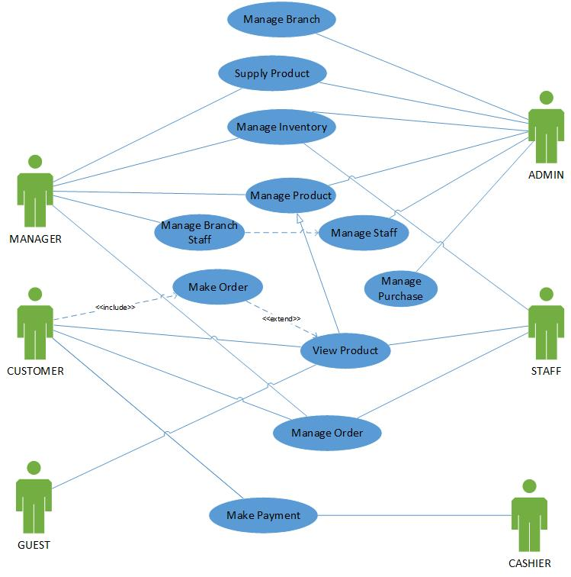

### **2.1.1 Drawbacks of the Existing Manual System**

The following major drawbacks have been identified in the existing manual management system.

* Confidential data is recorded in a log book.
* Critical calculations are done manually.
* Hand written contract documents (orders list, bill, payment vouchers, etc.)
* Inflexibility in finding details of order item.
* Improper customer history and documentation.
* Complex monitoring of business progress.
* Time wasting paper work.
* High labor cost.
* No easy payment methods (online payment, ez cash, shopping cards, etc.) for customer.
* Poor communication methods with the customers in business.
* No backups for the confidential data.

## **2.2 GATHERING TECHNIQUES**

In the software development, analysis part is very important to collect correct and accurate requirements for this system and analysis the requirements and identify the solution. Some information gathering techniques used for collecting the requirements are here. They are interviews, observation, questionnaires, site visit and etc. but in this study we used the interviews, observation and site visit to find requirements.

A questionnaire is mostly used to collect information from large number of people for same questions, this approach is unnecessary for this system. An interview is a formal face to face meeting with two or more peoples. It is primary technique for information gathering during the system analysis. We met the client (Saravanas Textile) to interview with them and asked about the manual system of their shop. In this technique user involvement is high and they easily interact with the system and we collect the clear business objectives.

Direct observe on work performance is an excellent means of gathering data. It is useful if the user is unable to explain clearly what they do or their requirements, can we get ideas to improve the process from their work. From site visit, we directly go to work place and observe their work and ask questions about their work and discuss the problems of their system and gather information. From these techniques clearly identify the requirements and problems of the current manual system and etc.

## **2.3 REQUIREMENTS GATHERING**

Requirements gathering or requirements eliciting is the process of addressing the needs and conditions of the new system.

### **2.3.1 Requirement Analysis for Manual System**

As mentioned earlier, from information gathering techniques we analyses their process, inquires the order and deliver, maintained data, manager level details and etc. The management is responsible for customer for the order product. Their entire product is store in their inventory department. When they receive order from customer via phone calls or personally they inquire about the order and send the information to stock department. They deliver the product to customer by vehicle. Cash payments, order details, customer details, stock details and etc., are recorded in paper and stored in file based system.

In their manual system they have manager level, stock and deliver. All the records are stored in papers by manual. There may be data duplication, not sure about correct data, there is no alert for minimum stock alert, no accurate data for giving discount to regular customer and they did not identify sales and non-sales product, staff details, salary details and etc. If they do not have accurate information it is very difficult to make promotion or increase salary for staff. From evaluating their current manual system they have spent lots of time to do their work.

### **2.3.2 Functional Requirements**

Functional requirements capture the intended behavior of the system. This behavior may be expressed as services, tasks or functions of the system required to perform. In product development, it is useful to distinguish between the baseline functionality necessary for any system to compete in that product domain and features that differentiate the system from competitors.

Requirements of the Saravanas Textile:

* Entering and storing the details of customers and orders.
* Obtaining detailed report view and print outs of day’s transactions.
* Obtaining periodical transaction report view and printouts.
* Sending promotional information to the customers via SMS.
* Updating the online customer profile.
* Advertising business promotional details.
* Blacklisting customers.
* Manage stock.
* Make penalty fee to deliver boy and in-charge for delay delivery.
* Alert news.
* Calculate salary.
* Get users feedback.
* Make friendly Graphical User Interface (GUI).

Requirements for customer:

* Customers can search the products.
* Customers make orders through online.
* Customer make payment through online payment/ez cash.
* Finding their order status.
* Make complains.
* Receiving promotional information from the company via SMS.
* Update the profile.
* Give feedback.

### **2.3.3 Non-Functional Requirements**

Non-functional requirements in system engineering and requirements engineering, a non-functional requirement is a requirement that specifies criteria that can be used to judge the operation of a system, rather than specific behaviors.

* Accuracy and consistency, these are very important non-functional requirements that should be considered when storing the details of customers and company calculating values.
* Security, there should be superior security mechanisms since the system stores very confidential information such as details of user profile, password of the customers and company account.
* Usability should be very much important in this project when developing the online user profile to the customers.
* Reliability, this is a non-functional requirement of the system users. There should be trustworthiness between the users and the system.
* Reusability and maintainability, in a case where the system needs any changes in the future, it should not be a tricky task. Proper documentation and using standard methods when developing the system will ensure this non-functional requirement.
* Authorized person only login into our system.
* Increase the sales and marketing.
* Reduce the labor cost and time.
* Easy to access the system.

### **2.3.4 Resource Requirements**

Hardware requirements:

* Pentium 4 computer.
* Printer.

Software requirements:

* Windows operating system.
* Wamp server (PHP 5.4.12, MySQL 5.6.12, Apache 2.4.4)
* Adobe Photoshop css5
* CSS
* JavaScript
* Microsoft Word
* MySQL
* Microsoft Project 2013

## **2.4 FEASIBILITY STUDY FOR THE PROPOSED SYSTEM**

Feasibility study is a very important process in order to find out the strengths, weaknesses, opportunities and threats of a proposed system to full fill the main business requirements. A detailed feasibility study was carried out regarding this system as following facts.

### **2.4.1 Legal Feasibility**

Since the proposed systems is a customer order the products through online system and deliver that order products to customers by Saravanas Textile, it has been analyzed to ensure that the system is in accordance to the sales and customer act of Sri Lanka.

### **2.4.2 Operational Feasibility**

The proposed system functions were analyzed to see whether they accomplish the business requirements.

### **2.4.3 Market Feasibility**

The proposed system will operate in Saravanas Textile situated in Jaffna district where there is a huge demand for their product business. The system is capable of facing the market demand.

### **2.4.4 Financial Feasibility**

The system is fully web based with very low hardware, maintenance and IT costs.

## **2.5 SIMILAR SYSTEMS**

Under the literature review part talking about online shopping system industries specially this project (Fashion shopping) topic. Now our world is technology world and day to day the technology is developing in high level. Mostly all the shop stores have online system for their business service. Fashion shops also have better online systems. Continually discussing some available best fashion website systems in local (Sri Lanka) and worldwide. These online systems are similar to our system. Then talking about what experts say in terms of building a good commercial web site, what they say about layout, text, images.

Now day’s lots of fashion stores have online shopping system websites. And that system have use full advance features also. Here, covering some fashion store web sites.

**ODEL**

ODEL is a Sri Lankan best and big Online Fashion Shopping store. This online fashion shopping system is related to our system. This fashion store web site link, <http://www.odel.lk>. The ODEL front page is shown in following Figure



Figure 2.1 ODEL main page

The ODEL is a special online cloth shopping business by locally and internationally. The site is giving services freely for their users but if anyone want to buy dress they want to pay some amount for the dress. This web based system is developed using asp.net. The site database is SQL.

This ODEL fashion store beginning of the day (1990) don’t have any web service only they have paper works. Then past few years they launch a web site that is normal web site. That’s web site don’t have any online shopping facilities. Before the past few years ODEL web site have only few functions. Now days this ODEL web site upgraded with very useful functions. Especially this website is covering website expert rules. Now days this website is one of the best commercial website now this website have lots of useful advance functions.

**Utsav**

Utsav is another best online fashion shopping website system. This also relates our system. Utsav fashion shop web link <http://www.utsavfashion.com>. The Utsav front page is shown in following Figure

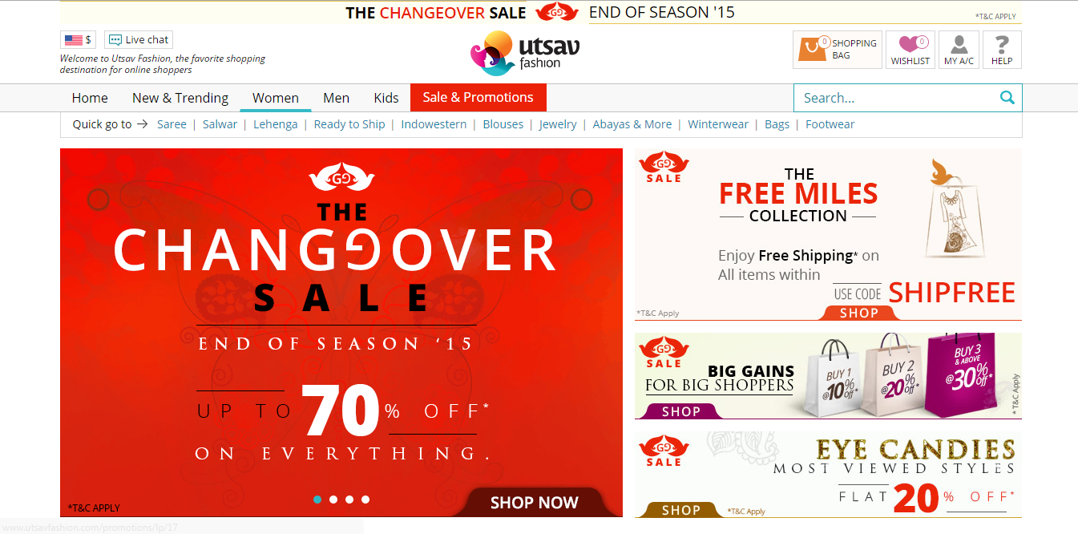

Figure 2.2 Utsav main page

Utsav fashion shop is based on United States of America. This fashion shop has really very nice design and lot of useful functions. Utsav online shopping system developed by mainly PHP language. This web system design parts developed by HTML language and java script.

These are the Utsav functions, when customer access Utsav website they change their country, change their currency and automatically calculate dress price. This function is it very helps to international customers.

Thus, there are no proper systems available in the literature for online book delivery system and with other easy payment method (ez-cash) in Sri Lanka. Hence thus motivated me to develop a system for online shopping system for Saravanas Textile.

# CHAPTER 3: DESIGN OF SOLUTION

During this phase the detailed specification for the proposed software is created. The Objects discovered during the analysis phase are refined, and the database is modeled. UML diagrams such as class diagrams, activity diagrams and sequence diagrams are used for this purpose. User interfaces are also designed. In earliest stages of automating information systems, mostly the main functions and transactions were automated. As time passed by developers began to automate other areas and support functions of business organizations as well. This helped greatly in improving the efficiency and thereby improving the productivity of organizations.

System designer converts the requirements from the requirement analysis phase into technical solutions. System design considers the software architecture, database design and interfaces design. There are several techniques exist to design a system, Such as

1. Structured design techniques
2. Object oriented design
3. Prototyping.
4. Rapid Application techniques
5. Joint Application Development

## **3.1 TECHNIQUES USED IN THE DESIGN**

When automating an Information System, it is needed to be developed in a methodical way to make it more robust and also to deliver a validated system to the client. A validated system is one that has no errors and also which satisfies the requirements of the client. A system development methodology is a very formal and precise system development process that defines a set of activities, methods, best practices, deliverables and automated tools for system developers and project managers, to use to develop and maintain an information system. [1]

There should be much approach such as waterfall model, incremental model, rapid application development, prototype model and etc. The waterfall model is suitable for projects which have clear and stable requirements. It has the possibility of cascading effects one stage to another stage in leaner cycle development process that best suited for where the requirements clearly defined. [2]

Incremental model, whole system is divided into separate sub-system and these sub-systems implemented separately. In this approach each sub-system is developed separately and development liner approach. This system used for large and complex system. The rapid application development is one of the incremental method, it based on technique that speedup the system development with high user involvement. [3] The prototyping model is better understanding on how to develop the system. It helps to clarify the requirements that are stable or unstable requirements. It has two types, one is throw-away prototype it is suitable for vague and stable requirements and another type is evolutionary prototyping that suitable for vague and unstable requirements. We used the evolutionary prototyping model to develop our system. [4][5][6]

The prototyping model is shown in following Figure 3.1 Prototype Model:

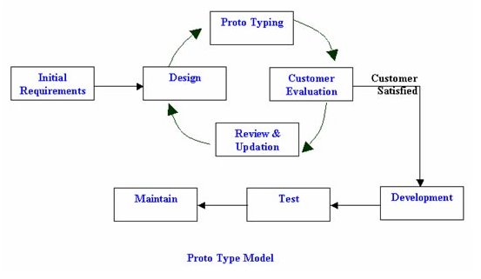

Figure 3.1 Prototype Model

## **3.2 ALTERNATE SOLUTIONS**

In software development all the system is basically divided into three categories they are standalone, network based and web based system.

The standalone system most suitable for run with in small area using personal computers and work stations, so the standalone application run only a specific environment. You will test complete application broadly in categories like GUI, functionality, load and backend (database).

The network based application usually developed for Local Area Network (LAN). In network based, application is loaded on server machine while the application exe on every client machine. You will test broadly in categories like, GUI on both sides, functionality, load, client-server interaction and backend (database). This environment is mostly used in Intranet networks. In network based application in connected mode, menu driven and has limited number of users can access.

The web application is accessed over a network connection using HTTP. Application is loaded on the server whose location may or may not be known and no exe is installed on the client machine, you have to test it on different web browser. An application in which all or some parts of the software are downloaded from the web each time it is run in user’s web browser. The web based application is Uniform Resource Locator (URL) driven; disconnected mode and unlimited number of users can access the application from any various places.

In this system the online shopping system for Saravanas Textile has many branches and many customers in various place, they want to access the system in their places. The shop like to centralized the backend (database) in their head office and provide the system to all users in simultaneously. For these reasons the shop has decided to develop the system in web based.

## **3.3 PROCESS DESIGN**

The design gives the solution for requirements analysis, based on this design to develop the system. This design was divided into three stages:

* Database design
* Application architecture design
* Interface design

### **3.3.1 Database Design**

Database design is done through data modeling. The database designing is done to specify the structure of the object of the system. To avoid the data redundancies the every table of the database were normalized to third normal form.

In normalization there is several level of normal form but we mostly used first three normal form. First normal form (1NF), eliminate duplicative columns from the same table and create separable tables for each group and identify the unique column or set of columns it is called as primary key for that table. Second normal form (2NF), if any non-key attributes are functionally depended on just a part of the key was remove and create separate table and connect both table with foreign key. Thus 2NF can only be violated only when a key is composite key. Third normal form (3NF), remove columns that are not depend upon the primary key.

After third normal form most of the table mostly avoids the data redundancy, if any additional other normal form will be used. I drew the Entity Diagram by MySQL. Our system ER diagram is shown in following Figure ER Diagram:

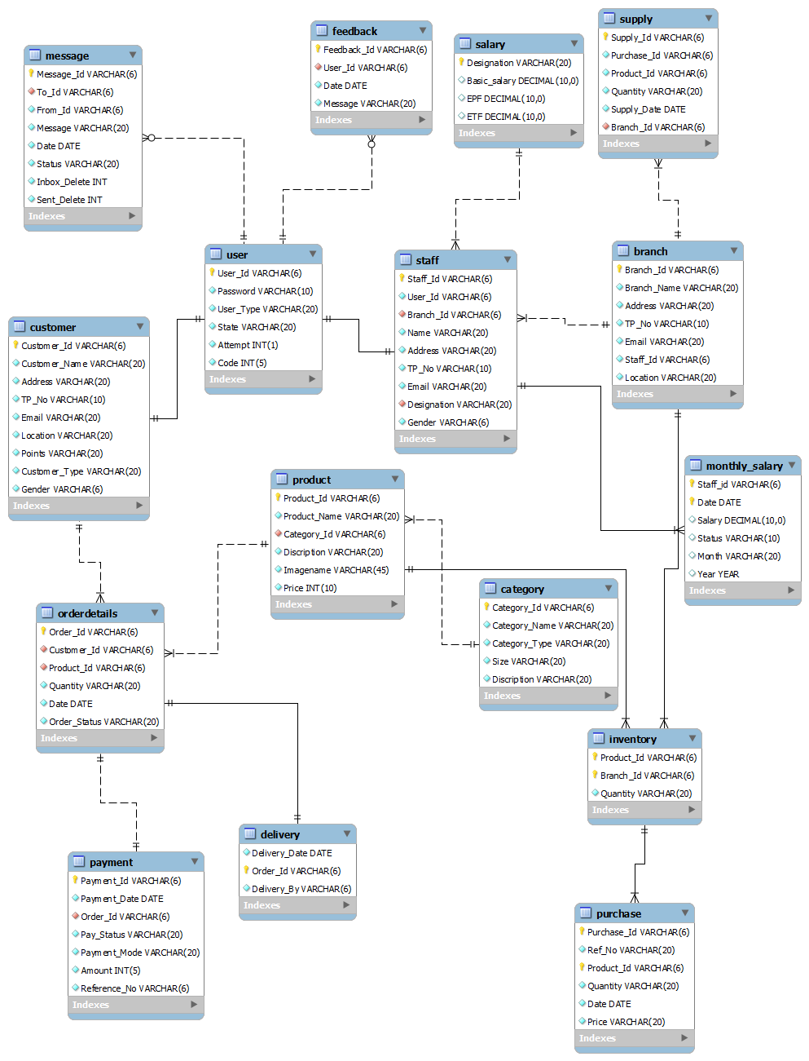

Figure 3.2 ER Diagram

### **3.3.2 Application Architecture Design**

This design describes the functionality and task of the system are connected into sub system. In this design we draw activity, class, sequence and use-case diagram. I used the Microsoft Visio Professional 2013 to draw those diagrams.

**Use-case diagram:**

It is simply represent the user’s interaction with the system, summarized the relationship between use-cases, actors (users) and systems. Our system use-case diagram is shown in following Figure Use-case Diagram:

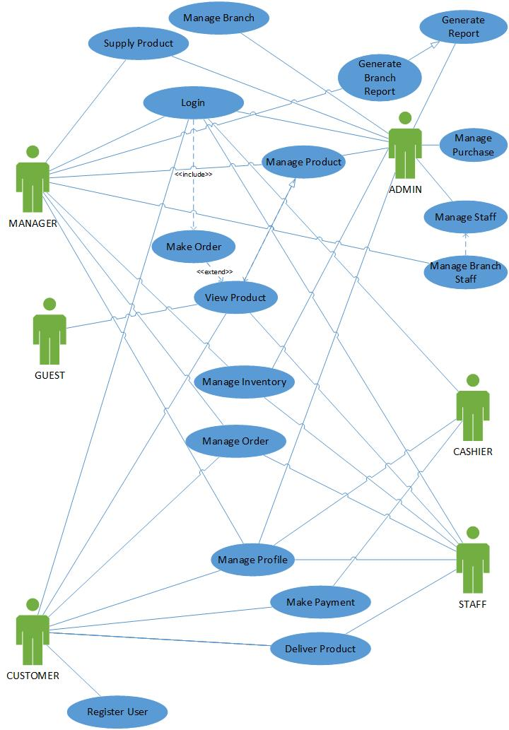

Figure 3.3 Use-case Diagram

### **3.3.3 Interface Design**

In this Interface Design section we provide the user interface of our system online shopping system. Our user interface, feels simple and easy to access, provide the guide to access the system and have icons, button and navigation to clearly shown to the user to access the system.

**Main Screen**

The following Guest Page, show the home page of our system. In home page, there are some tabs such as About Us and Contact Us. The Home page, describes about our products with picture explanation and also lists down the products what are sold by them from our system. In about us tabs, describe about the company. In contact us tab contains contact details. Our main screen has some access link such as Home, Login, and Register. The login permits the user to have access to the system. The login form has forget password link, provides to user to get password. In forget password link we enter User ID, register hand phone number, and the system send verification code to register hand phone, after verification the system send a password to the user via SMS (Short Message Service) to register hand phone number. From Register Link, new user can register to our system as customer.

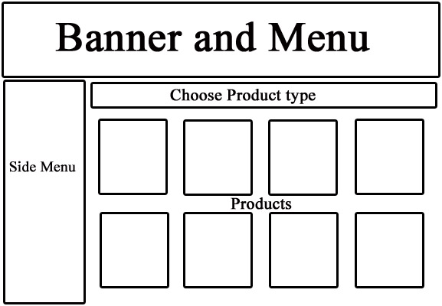

Figure 3.4 Main Screen – Layout Concept Design

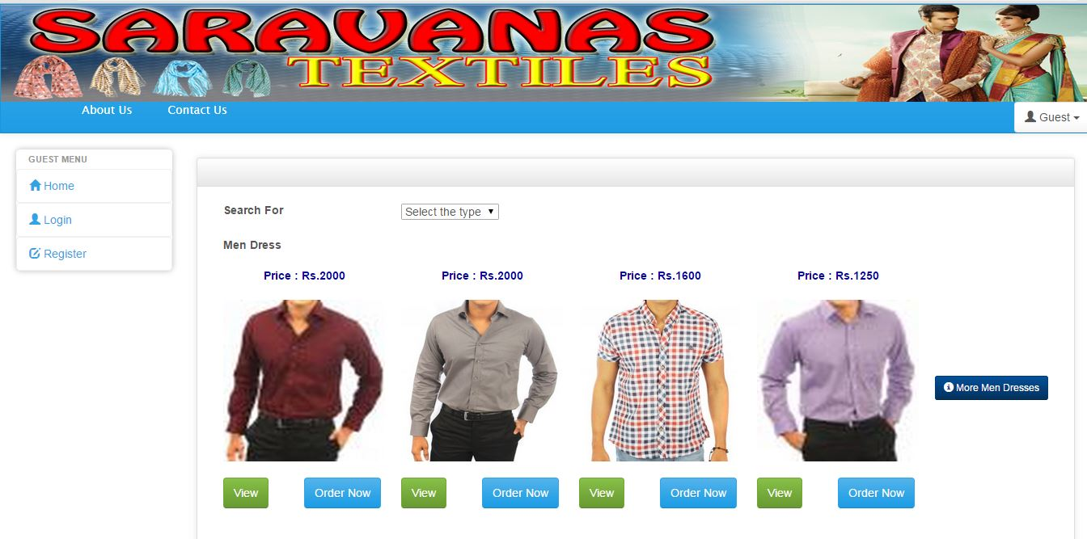

Figure 3.5 Main Screen

**Login Form**

The login screen is shown on following Login.

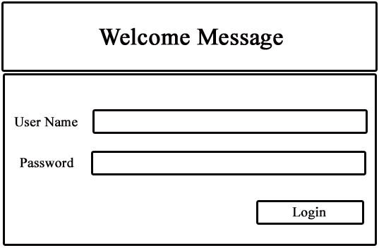

Figure 3.6 Login Screen – Layout Concept Design

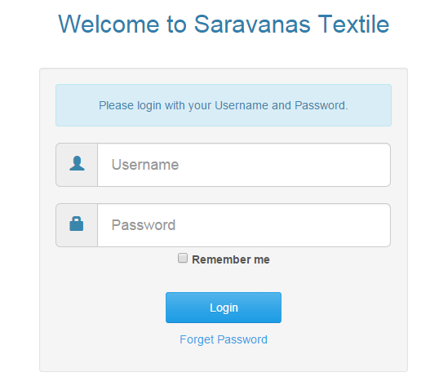

Figure 3.7 Login

**Forget Password**

The forget password screen is shown on following Forget Password.

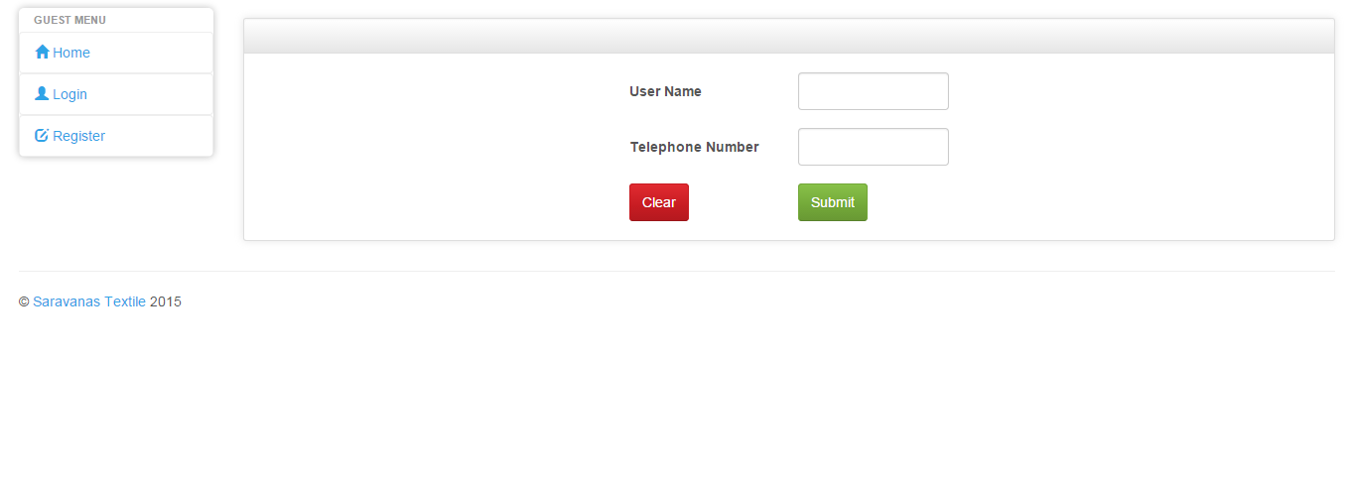

Figure 3.8 Forget Password

**Register**

Register screen is shown on following Figure Register New Customer.

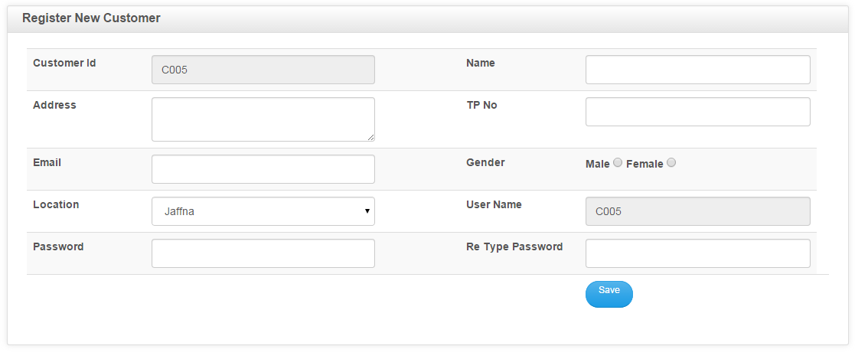

Figure 3.9 New Register

**Customer Interface**

After user login as customer the customer interface screen show the customer menu page and common body page. The customer interface screen is shown on following Customer Screen.

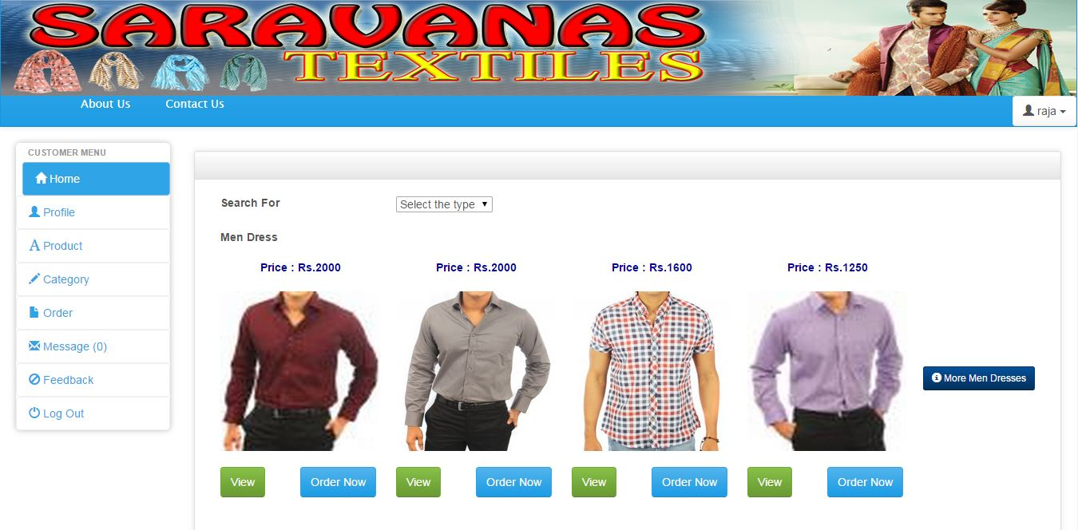

Figure 3.10 Customer Screen

The customer menu page has some link such as Home, Profile, Product, Category, Order, Message, Feedback and Logout. The go home link is navigating the interface to main screen. The product link shows the product details. The order link provide a make order form for make order through online. The profile link provides the details about the login customer details. The message link provides the message details of that login customer.

**Product Details**

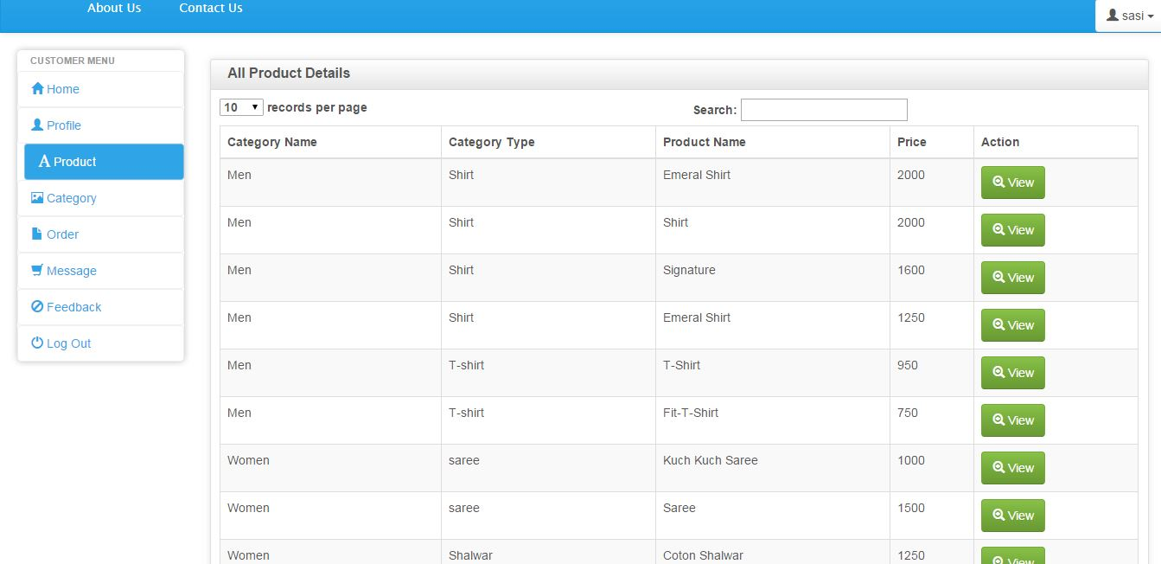

Figure 3.11 Product Details

**Make order form**

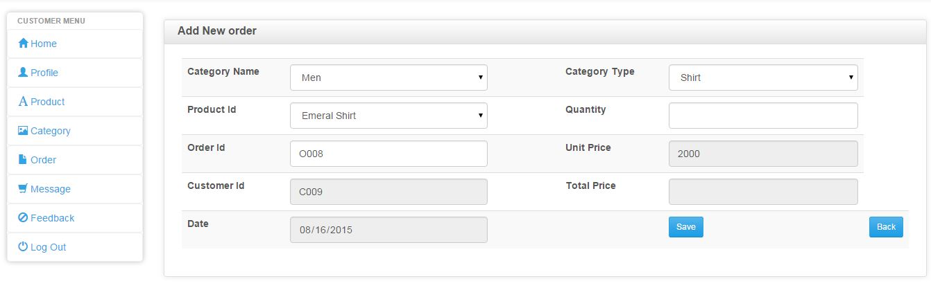

Figure 3.12 Order Form

**Administration Interface**

After user login as admin the Administration interface show the administration menu page and common body page. The administration interface is shown in the following Administration Screen.

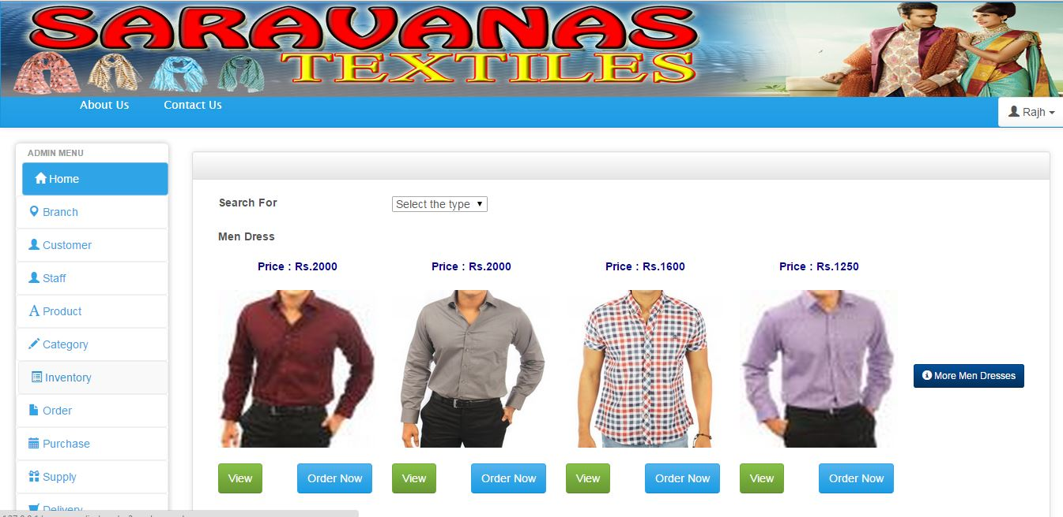

Figure 3.13 Administration Screen

The administration menu page has some link such as Home, Customer, Staff, Branch, Product, Category, Inventory, Order, Purchase, Supply, Delivery, Message, Feedback, Monthly Salary, Salary, Reports and Logout. The home link is navigating the screen to main screen. The staff link administrator can create new staffs and shows the staff details. The order link provide a make order form to make order through online. The product link provides a form to add any new product to sale from our system. From branch link administrator can create new branch of our system. The salary link provides form to add salary for different type of user.

**Add New Product**

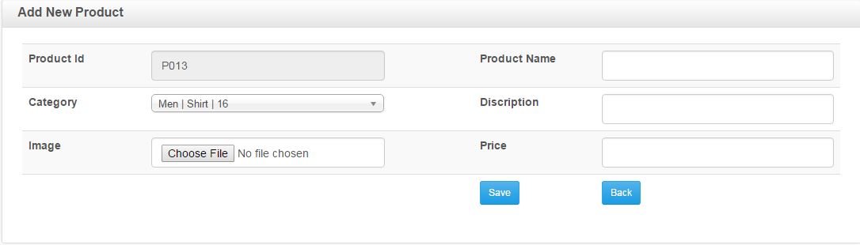

Figure 3.14 Add New Product

**Add New Branch**

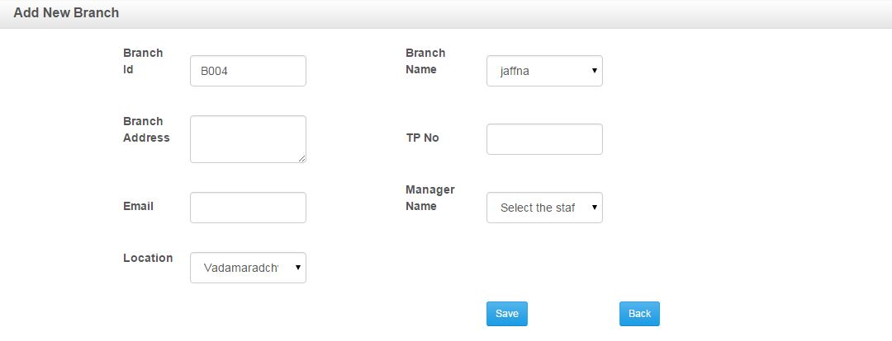

Figure 3.15 Add New Branch

**Manger Interface**

After user login as branch manager the manager interface turns to manager menu page and common body page. The manager interface is shown in following Manager Screen.

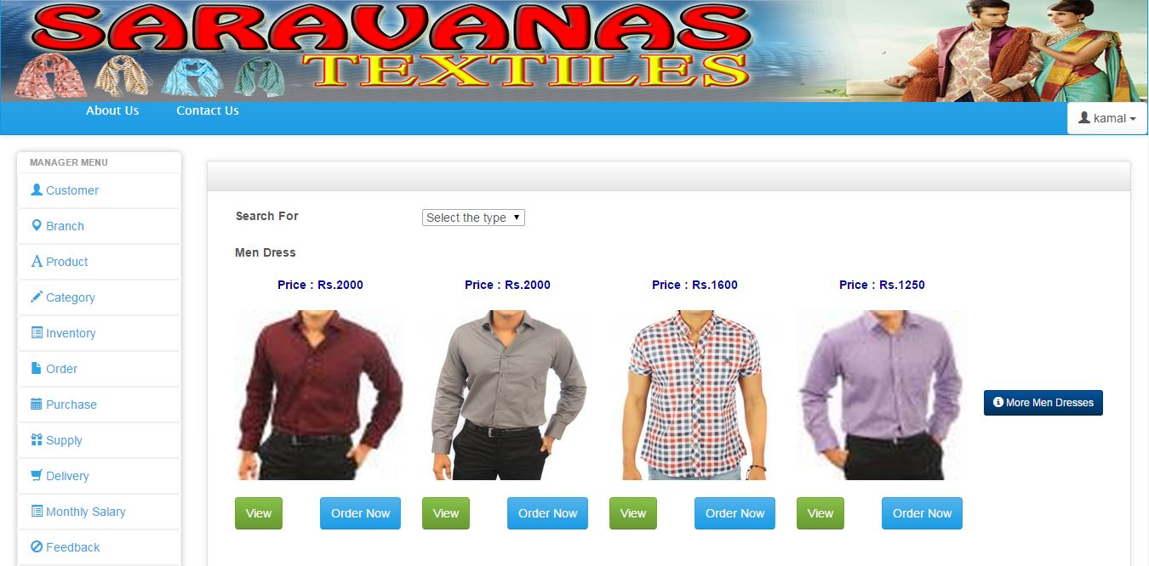

Figure 3.16 Manager Screen

The manager menu page has some access link such as Home, Customer, Branch, Product, Category, Inventory, Order, Purchase, Supply, Delivery, Monthly salary, Feedback, Message, Report and logout. The customer link provides a form to create a new customer under that login branch manager area. The delivery link provides a form to create a new deliver under that login branch manager area.

**Add New Delivery**

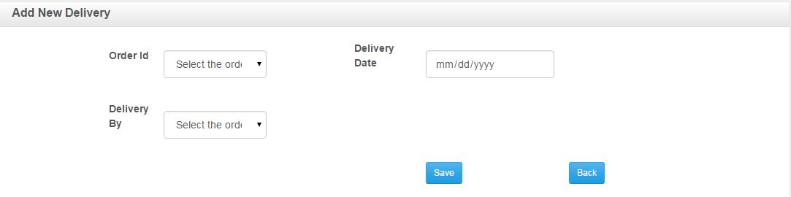

Figure 3.17 Add New Delivery

**Salary Details**

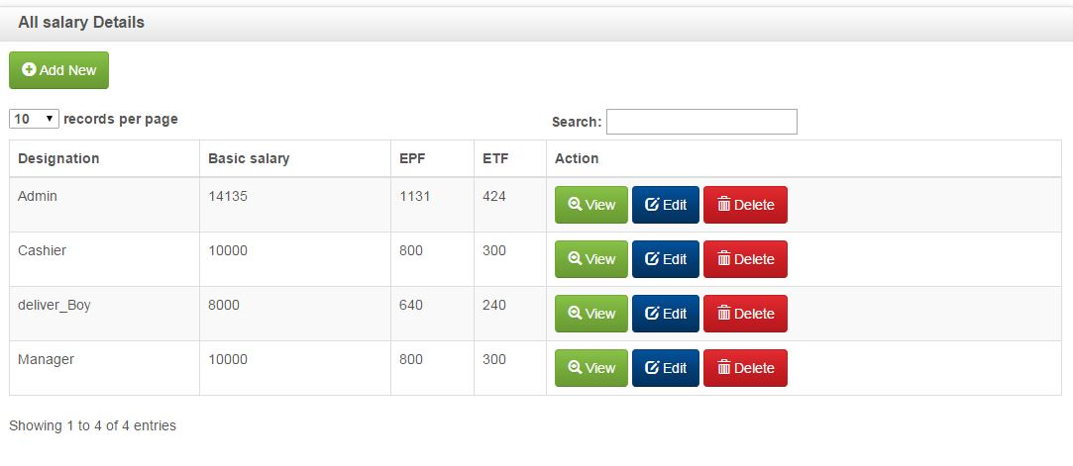

Figure 3.18 Add New Salary

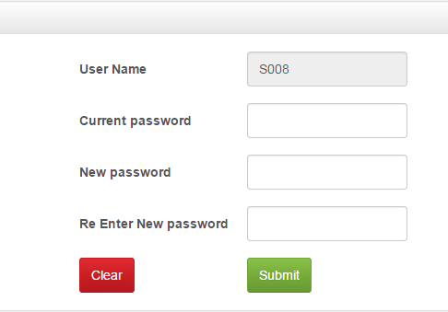The every user profile has a link to change their password. That change password link is shown in following Change Password.

Figure 3.19 Change Password

**Report**

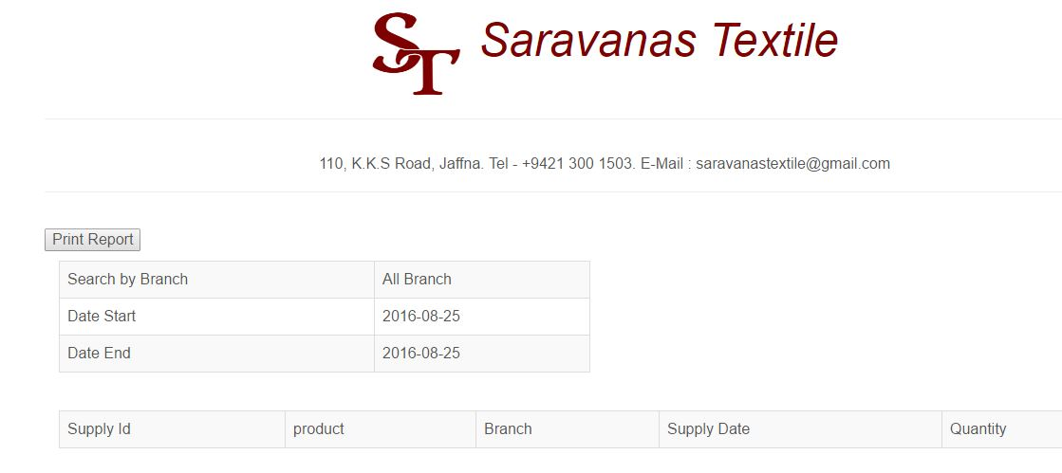

Figure 3.20 Report

# CHAPTER 4: IMPLEMENTATION

In this chapter implementation, we describe about the activities which were carried out during the development of our online shopping system. After design stage, the result of the design stage is transformed into physical design and we implemented that result of design stage.

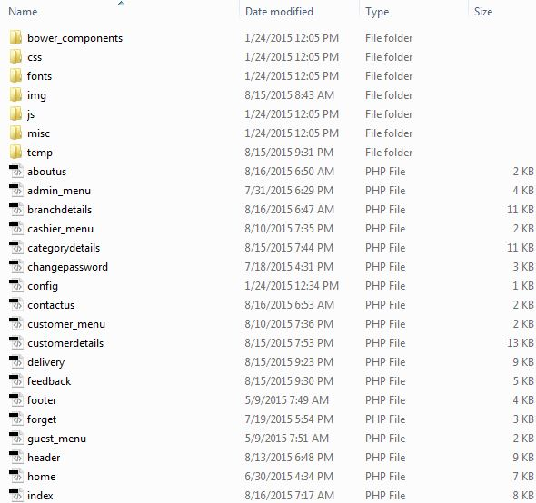

## **4.1 THE DEVELOPMENT ENVIRONMENT**

The hardware and software utilized for our development are listed below

### **4.1.1 Hardware Requirements**

* Pentium 4 or above computer.
* 2GB or higher RAM (Random Access Memory).
* 160GB or above Hard disk

### **4.1.2 Software Requirements**

* Windows operating system
* WampServer (PHP 5.4.12, MySQL 5.6.12, Apache 2.4.4)
* Adobe Dreamweaver CS5.5
* Adobe Photoshop CS5
* CSS (Cascading Style Sheet)
* JavaScript

## **4.2 CODE AND MODULES STRUCTURE**

In this system, code and modules divided into user management, inventory management, staff management, order management and deliver management. User management considers about add new customer or branch manager, manage their profile and change password.

Inventory management considers about order, payment and staff salary. In staff management sector, managing staff, printing report in various categories such as daily, monthly and yearly are included. Order management considers about sent details of the order via SMS, sending verification code to customer and calculating the orders delivery time. Deliver management considers about arrangement of delivery person to deliver the order to customer’s door in time.

## **4.3 CODE FEATURES**

In this section, it lists down the main coding of the online shopping system and describes about the coding. In code listing the system has utilized PHP, CSS and JavaScript coding.

### **4.3.1 Database Connectivity**

When developing the system, first we want to connect the system with database. We used the mysql_connect code to connect the local host. After the success of the connection to local host, we want to connect the database. We used the mysql_select_db code to connect the database.

Database connection code,

<? php

$host = 'localhost'; //host name

$user = 'root'; //username

$pwd = ''; //password

$database = 'distribute'; // database name

$con = mysql_connect ($host, $user, $pwd);

if(!$con)

{

die ('connection failed'.mysql_error());

}

$selectdb=mysql_select_db($database, $con);

if(!$selectdb)

{

die('database failed'.mysql_error());

}

?>

### **4.3.2 Login to System**

This login has to use authenticate the users. When we enter username and password correctly system displays their user interface. If we enter username or password wrong the system will provide a message box with meaningful message. If we enter wrong username or password more than three times, then the system automatically goes to forget password page.

**Login code,**

<?php

include("config.php");

if(!isset($_SESSION))

{

session_start();

}

if(isset($_POST['btn_submit']))

{

$username=$_POST['txt_username'];

$password=$_POST['txt_password'];

$sql="SELECT * FROM user WHERE User_Id='$username' AND Password='$password'";

$result=mysql_query($sql) or die(mysql_error());

$n=mysql_num_rows($result);

$sql1="SELECT * FROM user WHERE User_Id='$username'";

$result1=mysql_query($sql1) or die(mysql_error());

$row1=mysql_fetch_assoc($result1);

if(mysql_num_rows($result1)==1)

{

if($n==1)

{

$row=mysql_fetch_assoc($result);

$usertype=$row['User_Type'];

$_SESSION['username']=$username;

$_SESSION['usertype']=$usertype;

$sql2="UPDATE user SET Attempt='0' WHERE User_Id='$username'";

$result2=mysql_query($sql2) or die(mysql_error());

if(isset($_GET["od"]))

{

$w1=$_SESSION['w1'];

$w2=$_SESSION['w2'];

$w3=$_SESSION['w3'];

header("location: index.php?pg=orderdetails.php&option=new&w1=".$w1."&w2=".$w2."&w3=".$w3);

}

else

{

header("location: index.php?pg=home.php");

}

exit;

}

else if($row1["Attempt"]<3)

{

$sql2="UPDATE user SET Attempt=Attempt+1 WHERE User_Id='$username'";

$result2=mysql_query($sql2) or die(mysql_error());

?>

<div class="alert alert-danger">

Please login with correct your Username and Password.

</div>

<?php

}

else if($row1["Attempt"]>=3)

{

echo '<script> alert("You attempt more than three.... Please Give Your Phone number to reset password"); window.location.href="index.php?pg=forget.php&username='.$username.'"; </script>'; // if enter wrong user name or password

}

}

else

{

?>

<div class="alert alert-danger">

There is no such username.

</div>

<?php

}

}

?>

<?php

$no_visible_elements = true;

include('header.php');

?>

<div class="row">

<div class="col-md-12 center login-header">

<h2>Welcome to Saravanas Textile</h2>

</div>

<!--/span-->

</div><!--/row-->

<div class="row">

<div class="well col-md-5 center login-box">

<div class="alert alert-info">

Please login with your Username and Password.

</div>

<form class="form-horizontal" action="" method="post">

<fieldset>

<div class="input-group input-group-lg">

<span class="input-group-addon"><i class="glyphicon glyphicon-user blue"></i></span>

<input type="text" class="form-control" name="txt_username" id="txt_username" placeholder="Username">

</div>

<div class="clearfix"></div><br>

<div class="input-group input-group-lg">

<span class="input-group-addon"><i class="glyphicon glyphicon-lock blue"></i></span>

<input type="password" class="form-control" name="txt_password" id="txt_password" placeholder="Password">

</div>

<div class="clearfix"></div>

<div class="input-prepend">

<label class="remember" for="remember"><input type="checkbox" id="remember"> Remember me</label>

</div>

<div class="clearfix"></div>

<p class="center col-md-5">

<button type="submit" class="btn btn-primary" name="btn_submit">Login</button>

</p>

<p class="center col-md-5">

<a href="index.php?pg=forget.php"> Forget Password </a>

</p>

</fieldset>

</form>

</div>

<!--/span-->

</div><!--/row-->

<?php require('footer.php'); ?>

### **4.3.3 Forget Password**

This code is used to send a password to user mobile phone number with verification when user forget password. When user enters correct user id and register mobile phone number system send a code to mobile phone for verification, after correct verification system send a password to the user mobile phone number. If we enter wrong user id or mobile phone number, system display the alert message with meaningful message.

**Forget password code,**

<?php

if(isset($_GET['username']))

{

$forgetusername=$_GET['username'];

}

else

{

$forgetusername="";

}

if(isset($_POST["btnsubmit"])) // forget password start

{

global $phonenumber;

$forgetusername=$_POST['username']; //Get the username

$sql1="SELECT * FROM user WHERE User_Id='$forgetusername'";

$result1=mysql_query($sql1) or die(mysql_error());

$row1=mysql_fetch_assoc($result1);

if($row1["User_Type"]=="customer")

{

$sql2="SELECT * FROM customer WHERE Customer_Id='$forgetusername'";

$result2=mysql_query($sql2) or die(mysql_error());

$row2=mysql_fetch_assoc($result2);

$phonenumber=$row2["TP_No"];

}

else

{

$sql2="SELECT * FROM staff WHERE Staff_Id='$forgetusername'";

$result2=mysql_query($sql2) or die(mysql_error());

$row2=mysql_fetch_assoc($result2);

$phonenumber=$row2["TP_No"];

}

$entertpnum=$_POST["txtphonenumber"]; //get the phone number from form

if($phonenumber==$entertpnum)

{

$phonenumber="94".$phonenumber;

$user = "94775129559";

$password = "1166";

$text = urlencode("Your Password is :".$row1["Password"]);

$to = $phonenumber;

$baseurl ="http://www.textit.biz/sendmsg";

$url = "$baseurl/?id=$user&pw=$password&to=$to&text=$text";

$ret = file($url);

$res= explode(":",$ret[0]);

if (trim($res[0])=="OK")

{

echo "<script> alert('Please Check Your Phone'); window.location.href='index.php?pg=login.php';</script>";

}

else

{

echo "Sent Failed - Error : ".$res[1];

}

}

else

{

echo "<script> alert('Your Telephone number is wrong'); </script>";

}

}

?>

### **4.3.4 New Customer Register Code**

If the user enters all correct information the system insert the details into user table and customer table. If we enter wrong, the system provide an alert message box with meaningful message.

**New register code,**

<?php

if(isset($_GET['option']))

{

if($_GET['option']=="new")

{

if($usertype=="guest" || $usertype=="admin"){

?>

<form id="form1" name="frmcustomerdetails" method="post"> <!-- new register form start-->

<div class="box col-md-12">

<table class="table table-striped">

<tr>

<td width="15%"><label>Customer Id</label>&nbsp;</td>

<td width="30%">

<?php

// get the last user id and generate new user id

$sql1="SELECT Customer_Id FROM customer ORDER BY Customer_Id desc";

$result= mysql_query($sql1) or die("error in sql1 part".mysql_error());

$row= mysql_fetch_assoc($result);

$Customer_Id=$row['Customer_Id'];

$count=mysql_num_rows($result);

if($count>=1)

{

$Customer_Id++;

}

else

{

$Customer_Id="C001";

}

?>

<input type="text" name="txtcusid" id="txtcusid" value="<?php echo $Customer_Id; ?>" readonly class="form-control">

</td>

<td width="10%"> </td>

<td valign="middle" width="15%"> <label>Name</label>&nbsp; </td>

<td valign="middle" width="30%"> <input type="text" name="txtcname" id="txtcname" class="form-control"> </td>

</tr>

<tr>

<td> <label>Address</label>&nbsp;</td>

<td> <textarea name="txtaddress" id="txtaddress" class="form-control"></textarea></td>

<td width="85"> </td>

<td width="115" valign="middle"> <label>TP No</label>&nbsp;</td>

<td width="278"> <input type="tel" name="txttpno" id="txttpno" class="form-control" ></td>

</tr>

<tr>

<td> <label>Email</label>&nbsp;</td>

<td> <input type="email" name="txtemail" id="txtemail" class="form-control"></td>

<td width="85"> </td>

<td width="115" valign="middle"> <label>Gender </label>&nbsp;</td>

<td width="278">

<label for="btnmale">Male </label>

<input type="radio" name="btngender" id="btngender" value="male" >

<label for="btnfemale">Female </label>

<input type="radio" name="btngender" id="btngender" value="female" >

</td>

</tr>

<tr>

<td><label>Location</label>&nbsp;</td>

<td>

<select name="txtlocation" id="select" class="form-control" >

<option value="Jaffna">Jaffna</option>

<option value="Nallur">Nallur</option>

<option value="Nelliyady">Thenmaradchy</option>

<option value="Chavakachery">Vadamaradchy</option>

<option value="Valikamameast">Valikamam East</option>

<option value="Valikamamnorth">Valikamam North</option>

</select></td>

<td width="85"> </td>

<td width="115" valign="middle"> <label>User Name</label>&nbsp;</td>

<td width="278"> <input type="text" name="txtuname" id="txtuname" value="<?php echo $Customer_Id; ?>" readonly class="form-control"></td>

</tr>

<tr>

<td> <label>Password</label>&nbsp;</td>

<td> <input type="password" name="txtpwd" id="txtpwd" class="form-control"></textarea></td>

<td width="85"> </td>

<td width="115" valign="middle"> <label>Re Type Password</label>&nbsp;</td>

<td width="278"> <input type="password" name="txtrpwd" id="txtrpwd" class="form-control"></td>

</tr>

<tr>

<td>&nbsp;</td>

<td>&nbsp;</td>

<td>&nbsp;</td>

<td>&nbsp;</td>

<td><input type="submit" name="btnsubmit" id="btnsubmit" value="Save" class="btn btn-primary btn-round btn-lg"></td>

<td>

<?php

if($usertype=="admin")

{

?>

<a href="index.php?pg=customerdetails.php&option=view"> <input type="button" name="btnback" id="btnback" value="Back" class="btn btn-primary btn-round btn-lg"></a>

<?php

}

?>

</td>

</tr>

</table>

</div>

</form> <!-- new register form end-->

### **4.3.5 Generate the Id**

Generate the new ID when we load any new entry form.

<?php

// get the last user id and generate new user id

$sql1="SELECT Customer_Id FROM customer ORDER BY Customer_Id desc";

$result= mysql_query($sql1) or die("error in sql1 part".mysql_error());

$row= mysql_fetch_assoc($result);

$Customer_Id=$row['Customer_Id'];

$count=mysql_num_rows($result);

if($count>=1)

{

$Customer_Id++;

}

else

{

$Customer_Id="C001";

}

?>

### **4.4 REUSED MODULES**

In this system, CSS and JavaScript are used for the date time picker and charisma-master is used to design forms, tables and form fields.

## **4.5 SECURITY**

This online shopping system is accessed by public and Saravanas Textile’s manager level users from various places and transforms many data, so it is important to maintain the security. The administration has full privilege to access the system, in other hand other users have less privilege than administration. From our system, only the registered user can access the system, the registered user uses their user ID and password to login and access the system. After registering in our system the new user can access the system

If the user try to login with wrong password, our system allows only three times. After three times, the system automatically loads the forget password page. From forget password web page the system verifies the user ID and registered mobile phone number and then send a password to user’s registered mobile phone number.

# CHAPTER 5: EVALUATION

The evaluation process carries out entire software development life cycle to achieve the user friendly system with satisfaction of user requirements. From this phase, all aspects of online shopping system were tested with sample data and validated.

The testing is very important to identify and detect error, to check whether the system is working properly or not, to validate the system and to verify that all the activities of the software is implemented correctly or not.

## **5.1 TESTING**

In testing there are many approaches available in software testing. But mainly there are two methods of testing, static and dynamic testing. Static testing is often implicit as proof reading, plus when programming tools/ text editor check source code, check syntax and data flow. The dynamic testing takes place when the program itself is running. The dynamic test may begin before the program is completed, in order to test particular sections of code and are applied to discrete functions or modules. Static testing involves verification, whereas dynamic testing involves validation. Together they help to improve software quality.

Software testing methods are traditionally divided into white-box and black-box testing. White-box testing tests internal structures or workings of a program. The black-box testing is examining the functionality of the system without any knowledge of internal implementation of the code. Giving input to the system and checking the output value with expected value specified in the test case.

In testing there are several levels of testing such as unit testing, integration testing, system testing and acceptance testing. [7]

### **5.1.1 Unit Testing**

Unit testing also known as component testing, refers to tests that verify the functionality of a specific section of code, usually at the function level. In an object oriented concept this is usually at the class level, and the minimal unit tests include the constructors and destructors. These types of tests are usually written by developers as they work on code (white-box style), to ensure that the specific function is working as expected.

### **5.1.2 Integration Testing**

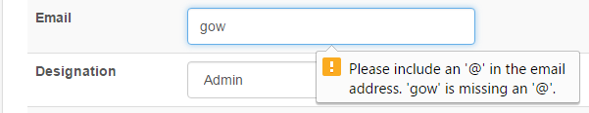Integration testing is any type of software testing that seeks to verify the interface between components against a software design. Software components may be integrated in an iterative way or altogether. Integration testing works to expose defects in the interface and interaction between integrated components. In integration testing there are several methods such as top-down testing, bottom-up testing and interface testing. Top-down testing means, first test top level components then the lower level components implemented and tested until lowest level reached. Bottom-up testing means, the lower level components are tested and then working up on modules until the final components is tested. Interface test means, it is done when modules or sub system are integrated and built with larger system.

### C:\Users\Thulasi\Desktop\thulashi.desi\Screenshot\phonecode.JPG

### C:\Users\Thulasi\Desktop\screen shot\missmatch newpwd.PNG

### **5.1.3 System Testing**

The system testing, tests a completely integrated system to verify that it meets its requirements. The system testing should ensure that the program, as well as working as expected, does not also destroy or partially corrupt its operating environment or cause other processes within that environment to become inoperative. [8]

### H:\thulashi.desi\username error.PNG

### **5.1.4 Acceptance Testing**

At last, system is delivered to the user for acceptance testing. The different testing are used and validated in different part of this project.

## **5.2 TEST PLAN FOR OUR SYSTEM**

Testing was done in each and every part of the system. The entire test plans were done before implementation on client side. Our test plan helps us to identify the error and fix it.

Our test modules were designed as follows,

* Guest module
* Administration module
* Manager module
* Staff module
* Customer module
* Cashier modules
* Common function module

## **5.3 TEST DATA**

The sample data were entered to the system to all modules need to be tested in order to test the function. We test the all form, view, manage and report with sample data. If we enter wrong input, system display meaningful error message.

## **5.4 ACCEPTENCE TESTING**

Online shopping system was tested in the client side, the system was implemented in the web server. User acceptance testing was carried out with real ordering and transactions. Some users were selected from my friends who are in IT and some common users also were selected. Selected user’s activities were monitored while they were working.

Final result of the acceptance testing is ensured that the system is very user friendly and easy to use by any user. In addition, it can be used in any platforms. Some feedbacks and suggestions also were given by the client. Finally, the overall project had satisfied the client. And client wishes that, some future works should be done to enhance the business activities of the shop.

# CHAPTER 6: CONCLUSION

In this system, online shopping system gave good knowledge to us and we go to next level of our career successfully. This project fed us with new knowledge and guided us to implement what we have studied throughout the previous semesters of my degree.

## **6.1 CRITICAL ASSESSMENT**

Our system was built using the technologies Object Oriented (OO) concept, HTML, CSS, PHP and JavaScript with back end MySQL.

The system was successfully satisfied with user requirements including their functional and non-functional requirements and client has accepted our project with fulfill of satisfaction. From this system, the management of the Saravanas Textile is facilitated to increase the sales of household products of the shop by getting orders through online with this management system, get updated by minimum stock alert every times. So easy to manage inventory of the shop, fine for delay deliver for every deliver person, staff salary, their promotion and allowance, get up to date reports to help make better management decision and support to management employees, receive order alerts through mobile phone to the admin of the shop and help to make necessary action about orders and identify the fast moving sales items and non-sales product items through the timely generated report, etc.

**6.2 LESSION LEARNT**

The knowledge gained throughout this project is really valuable and gave me an opportunity to work on a whole project from the initial phase to implementation stage. This project also gave me a chance to practice the theories which I leant on the entire three year of my Degree and also provided me with a chance to get the knowledge of the latest technologies that were developed such as HTML, PHP, jQuery, JavaScript and MySQL. Also I got a great deal of knowledge about reused modules and components in designing. Furthermore developing this project helped me to improve my technical, intellectual and also to upgrade my skills on the practical use of information technology. It also gave me an opportunity to collaborate with many people conversant in different categories of technical fields.

## **6.3 FUTURE WORK**

Our system satisfy client requirement but further more if we change some functions to make the system more quality. Now a day’s our country grows up in technology field, so we have to do some future works. These are some future works:

* Improve the security by using encryption methods.
* Allow the customer to make order with online shopping card.
* Allow more products and make agreement with other furniture, electrical, etc. product company to sale their product through our system.
* Developing our system similar to system ODEL, Utsav
* Generate more account reports, give more allowance calculation, etc.

# REERENCE

[1] Wikipedia, the free encyclopedia – Software development, [Online]

Available: <https://en.wikipedia.org/wiki/Software_development>

[2] Wikipedia, the free encyclopedia – Waterfall model, [Online]

Available: <https://en.wikipedia.org/wiki/Waterfall_model>

[3] Wikipedia, the free encyclopedia – Software prototyping, [Online]

Available: <https://en.wikipedia.org/wiki/Software_prototyping>

[4] Wikipedia, the free encyclopedia – Incremental modeling, [Online]

Available: <https://en.wikipedia.org/wiki/Incremental_build_model>

[5] Wikipedia, the free encyclopedia – Rapid application development, [Online]

Available: <https://en.wikipedia.org/wiki/Rapid_application_development>

[6] Wikipedia, the free encyclopedia – Software development process, [Online]

Available: <https://en.wikipedia.org/wiki/Software_development_process>

[7] Tutorials point – Software testing, [Online]

Available: [http://www.tutorialspoint.com/software_testing /](http://www.tutorialspoint.com/software_testing%20/)

[8] Wikipedia, the free encyclopedia – Software testing, [Online]

Available: <https://en.wikipedia.org/wiki/Software_testing>

# APPENDIX

## **Appendix A – System Documentation**

**Introduction**

We give instructions about how to install our system and database, and it helps the client in installation and maintenance.

Step 1: Double click on download file WampServer 2.4 and just follow the instruction. Everything is automatic.

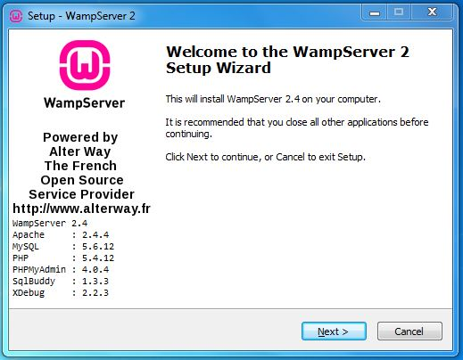

Figure A.1 Setup wizard

Step 2: After click next, accept the agreement and click next.

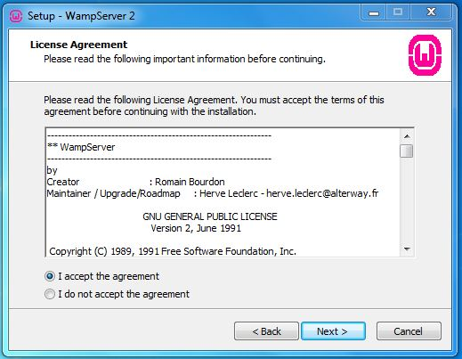

Figure A.2 Agreement

Step 3: Select the installation location of WampServer

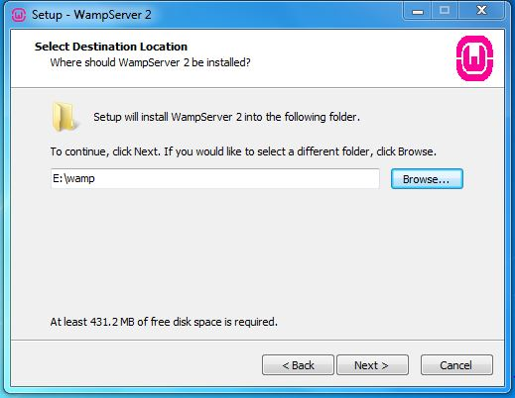

Figure A.3 Folder Location

Step 4: Click Install and It finish automatically.

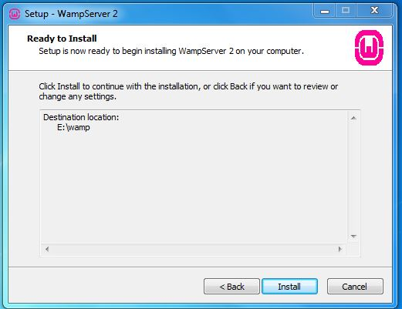

Figure A.4 Install

Step 5: After Install, start the WampServer in taskbar WampServer visible in green color. After green color, go and type in browser’s address bar “localhost or 127.0.0.1”.



Figure A.5 in Taskbar

Step 6: In browser, there is phpmyadmin under Tools heading, click that link and type username as “root” and password is blank. And click go button.

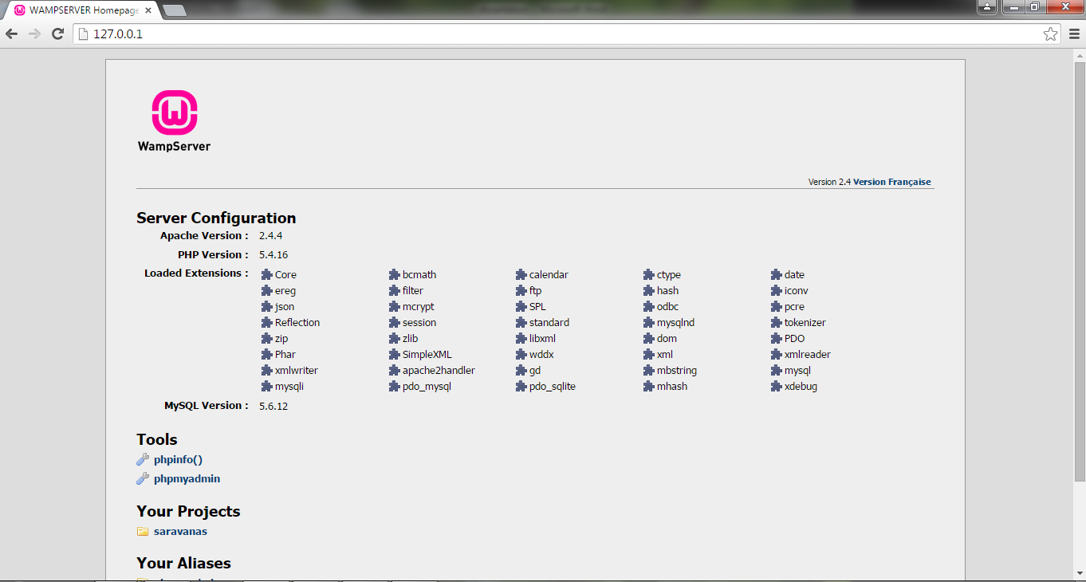

Figure A.6 Index Page of WampServer

Step 7: After login, click Import tab, in that tab click browse and select the database file distribute.sql file from pen-drive and click go button.

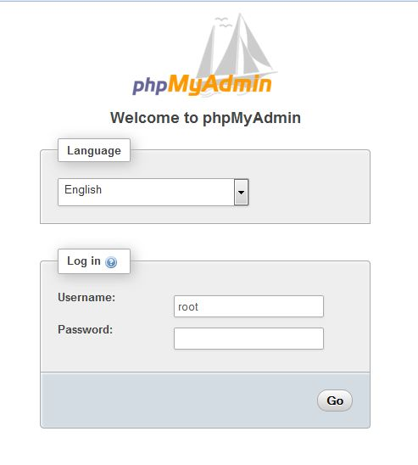

Figure A.7 Welcome Page

Step 8: You now successfully upload database,

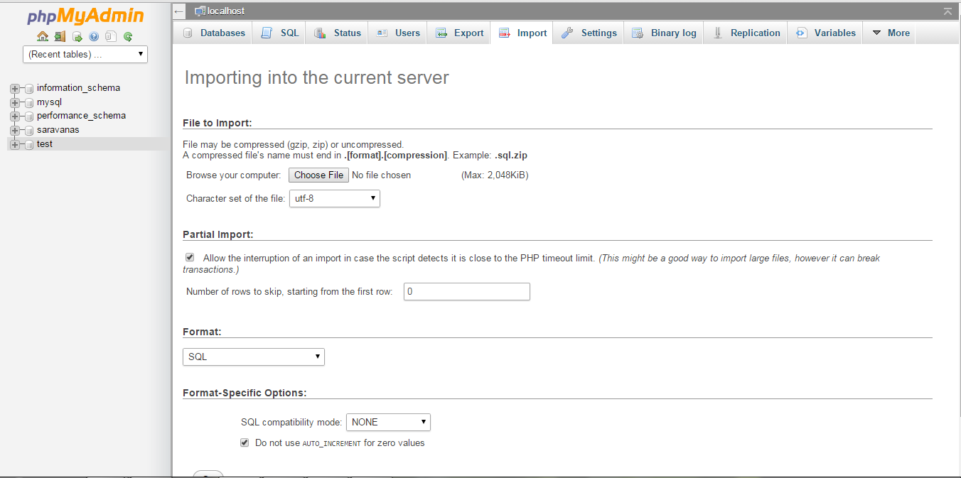

Figure A.8 Database Upload

Step 9: The “www” directory will be automatically created. According the Step 3, our www folder is under C:\wamp. In www folder we create a subdirectory and put our PHP files.

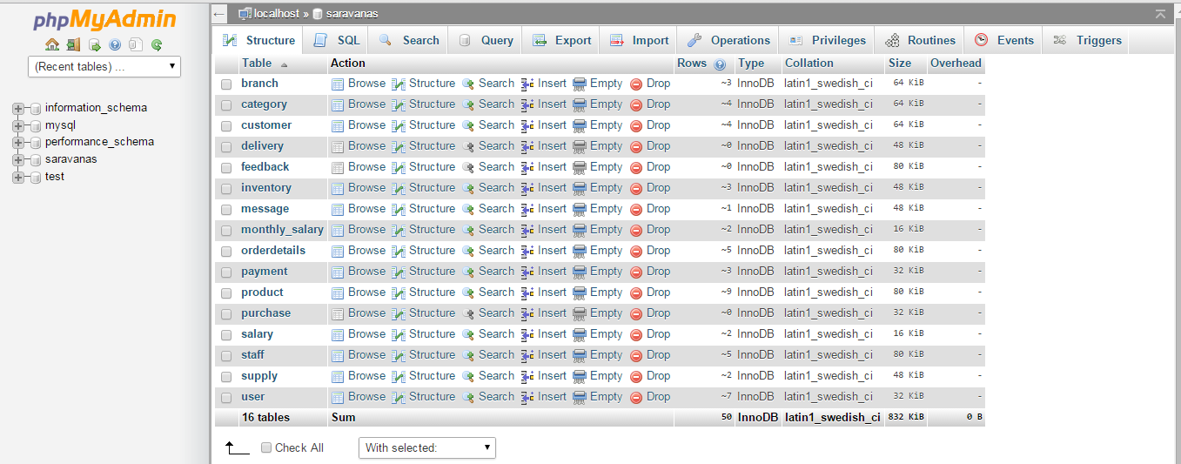

Figure A.9 Our Tables



Figure A.10 Php files

## **Appendix B – User Documentation**

This documentation gives a total explanation of our system online shopping system, how to handle this system.

**Guest Interface**

The following Guest Page, show the home page of our system. In home page, there are some tabs such as About Us and Contact Us. The Home page, describes about our products with picture explanation and also lists down the products what are sold by them from our system. About us tabs, describes about the shop. Contact us tab contains contact details. Our main screen has some access link such as Home, Login and Register. The login permits the user to have access to the system. The login form has forget password link, provides the user to get password. In forget password link we enter User ID, register hand phone number, and the system send verification code to registered hand phone, after verifying the system, send a password to the user via SMS (Short Message Service) to registered mobile phone number. From Register Link, new user can register to our system as customer.



Figure B.1 Guest Interface

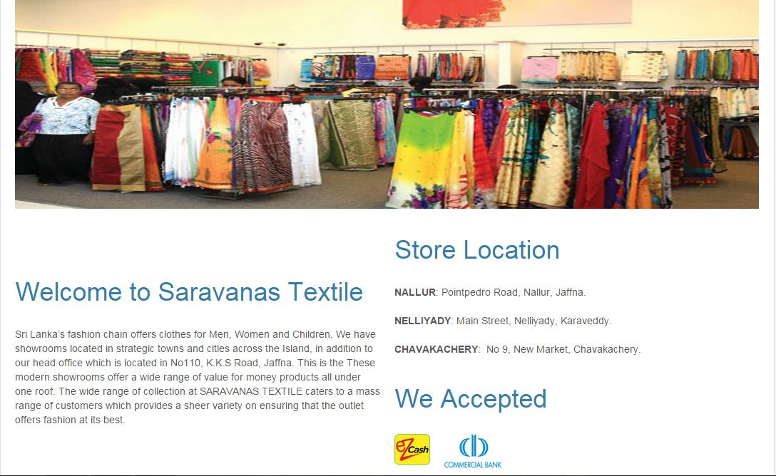 The About us is shown on following about Us.

Figure B.2 About Us

The Contact us is shown on following Contact Us.

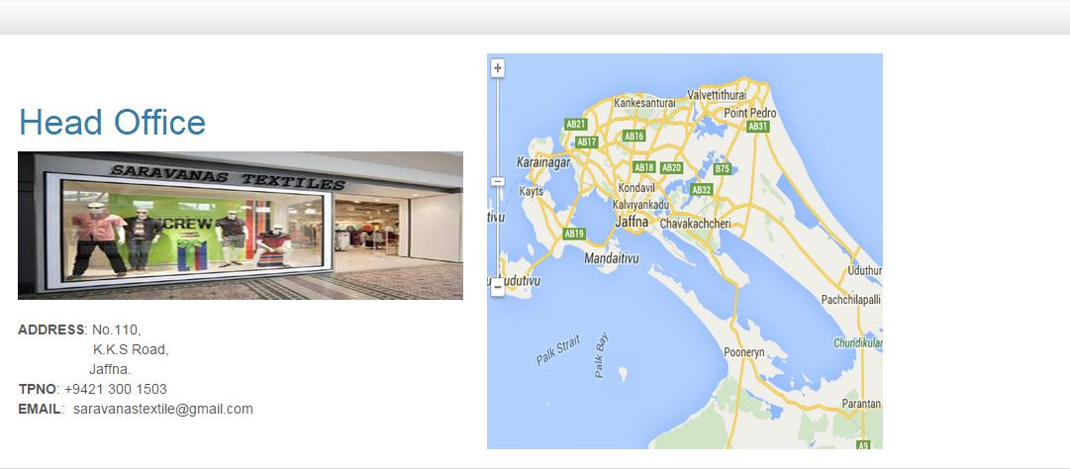

Figure B3 Contact Us

In additional, in Guest page facilitate Home, Login and Register. Through login, only the registered users will be allowed to enter our system.

**Login Form**

The login screen is shown on following Figure Login.



FigureB.4 Login

When registered user enters wrong username or password the system will provide an error message. It shows on following Username Error.

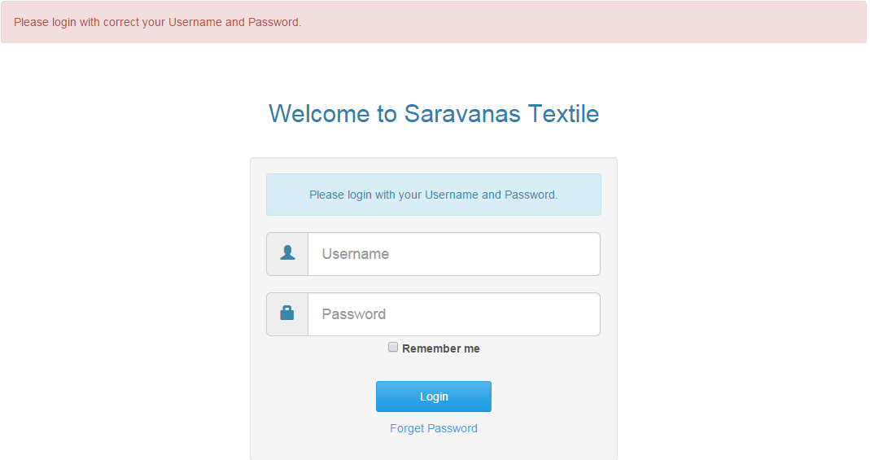

Figure B5 Username Error

If registered user, attempt more than three times to login this system, system will provide a message and redirect to forget password page. It is shown in following More Attempts.

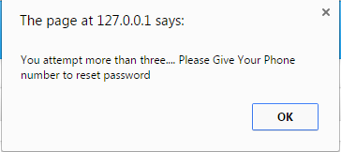

Figure B.6 More Attempts

In forget password form, enter the user ID and registered telephone number. If any wrong input, the system will provide error message. In telephone field we can insert telephone number only, texts are not permitted there. After entering the correct user ID and telephone number, system sends a verification code to telephone number and redirects to verification form.

If a wrong telephone number is entered,

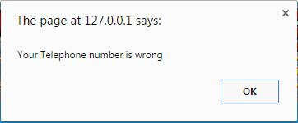

Figure B.7 Wrong Telephone Number

If a wrong telephone format is entered,

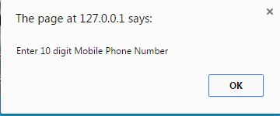

Figure B.8 Wrong Telephone Format

After entering the correct user ID and telephone number, system sends a verification code to telephone number and redirects to verification form.

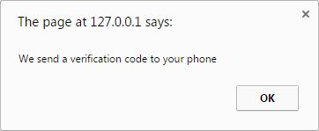

Figure B.9 Send Code

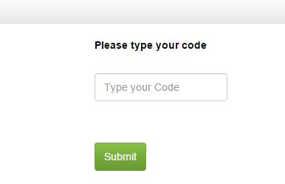

Figure B.10 Verification Form

In verification form, enter the code number and then system will check whether it is correct or wrong. If wrong displays the error message and redirect to index page. If your code no is correct, the system sends a password to user’s telephone number.

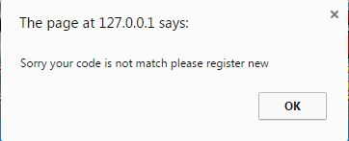

Figure B.11 Verification Code Error

Drag the icon next to your URL to the desktop to create the shortcut and have easy access next time.

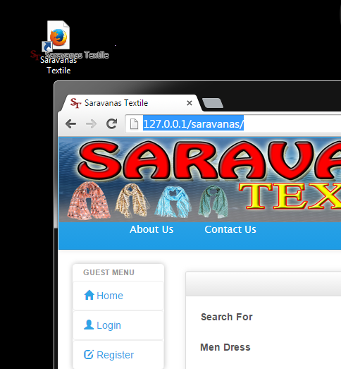

Figure B.12 Create the shortcut

**Administrator Interface**

The administration menu page has some link such as Home, Customer, Staff, Branch, Product, Category, Inventory, Order, Purchase, Supply, Delivery, Message, Feedback, Monthly Salary, Salary, Reports and Logout. The home link is navigating the screen to main screen. The staff link administrator can create new staffs and shows the staff details. The order link provides a make order form for making order through online. The product link provides a form to add any new product to sale from our system. From branch link, administrator can create new branch of our system. The salary link provides form to add salary for different types of user.



Figure B13 Admin Interface

The product link is only for administration. This link facilitate a form for add new product to this system. After entering the new product details then click the submit button, the system will provide a successful message. It shows in following Add New product.



Figure B.14 Add New Product

Staff interface has Add New staff. There are some options view, edit, delete. These options are used to add, view, edit and delete function. New Staff can be added by add new option. Staff details can be edited by the edit option and can be deleted by the delete option. It is shown in the following Staff Interface.

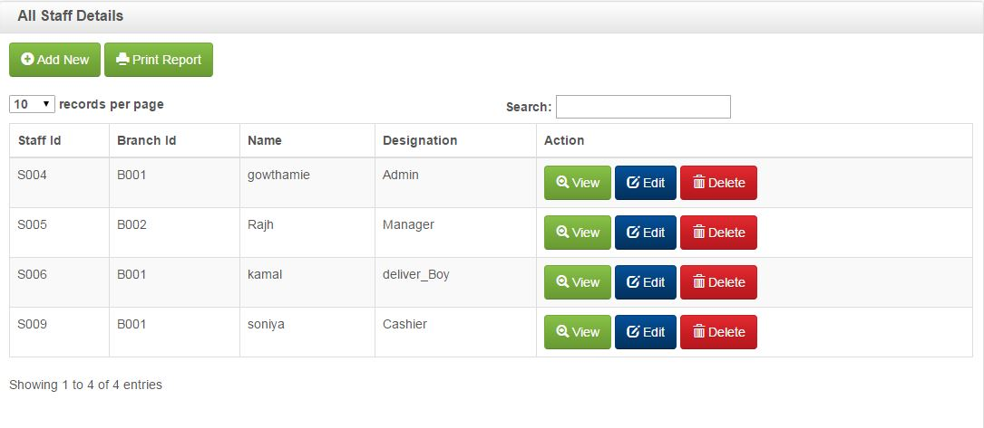

Figure B.15 Staff Interface

Add new staff option is only for administration purposes. From this link, there is a form for add new staff to this system. After filling details, administration submit the details, the system will display a successful message. It is shown in following Add New Staff.

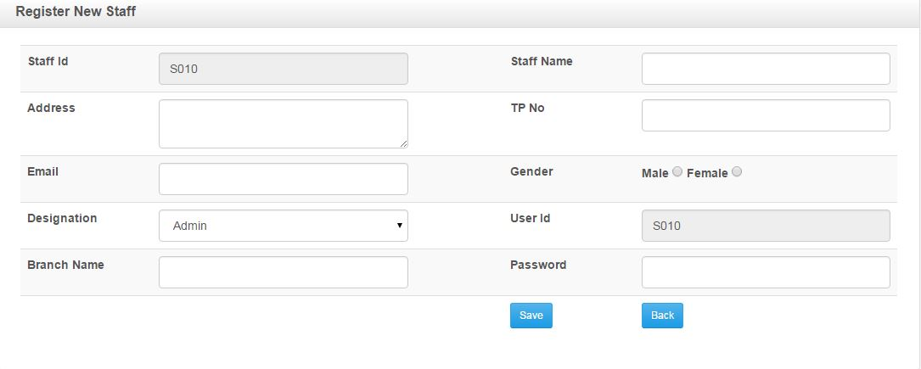

Figure B.16 Add New Staff

Conform message to delete function,

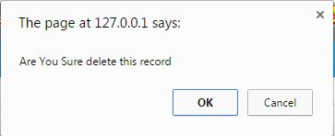

Figure B.17 Conform message to delete function

The profile links is same for every registered user. The profile link has details of users; they can change their details but through this system they cannot collect the administration details. The system has other users’ details and if they change their telephone number in profile then the system will send a code to new telephone number for verification, and redirect to verify form interface. In verification form you enter the code, if wrong code, the system will not change the telephone number and redirect to profile page. If enter correct code the system will change the telephone number. It is shown in following Profile

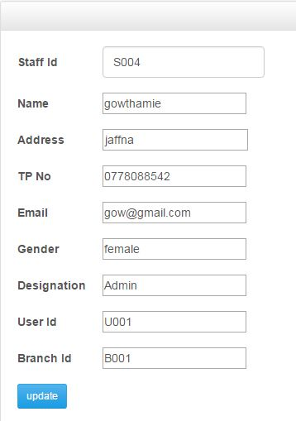

Figure B.18 Profile Interface

In profile link, there is an additional link for change password. As usual this change password link includes the current password, new password and retype new password. The system will check enter correct current password or not first and then check new password and retype new password are same or not. The system only allows the password character is more than six. If we make wrong input, system will provide a message. It is shown in the following Change password interface.

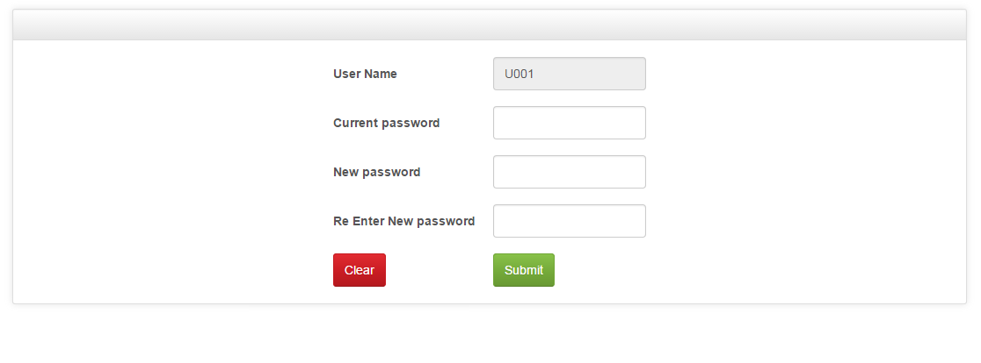

Figure B.19 Change Password Interface

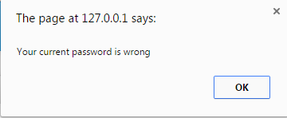

Figure B.20 Wrong Current Password

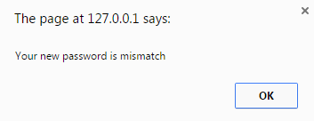

Figure B.21 Mismatch New Password

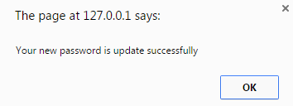

Figure B.22 Change Password

The message links also same for every registered users. In message link, there are two tabs such as compose and sent mail. The inbox link is activated as default page. From inbox link we can see our inbox mails and same way from sent mail tab we can see our sent mails. From compose tab, we can send a mail within our system. In “to” address field enter any registered user Id. From address is login user ID it is read only. If we used any non-registered user ID, the system will provide a message. After successful message sent, system will display a message.

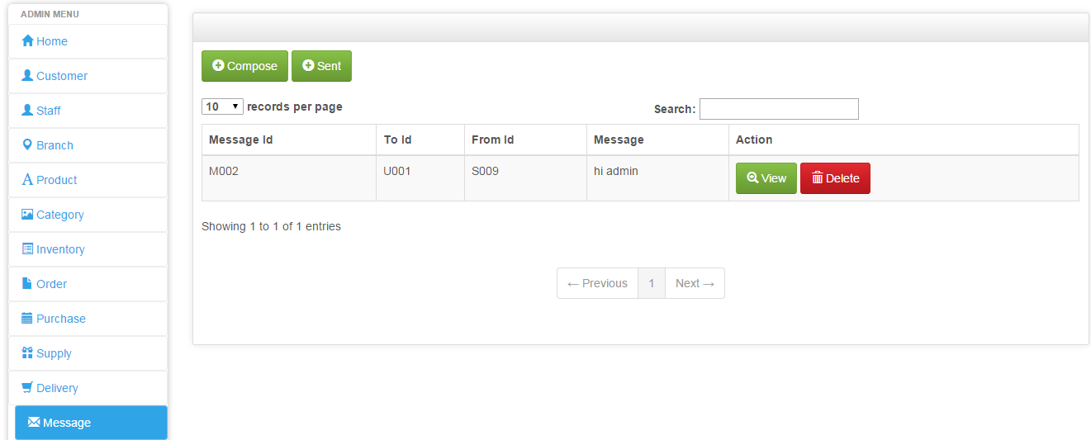

Figure B.23 Message Interface

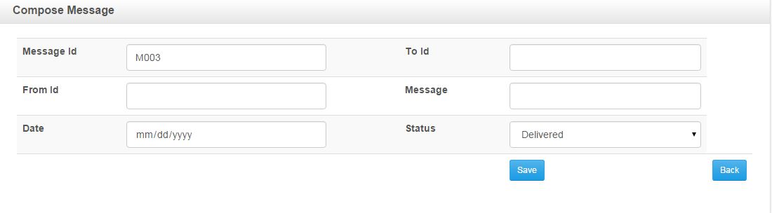

Figure B.24 Compose Message Interface

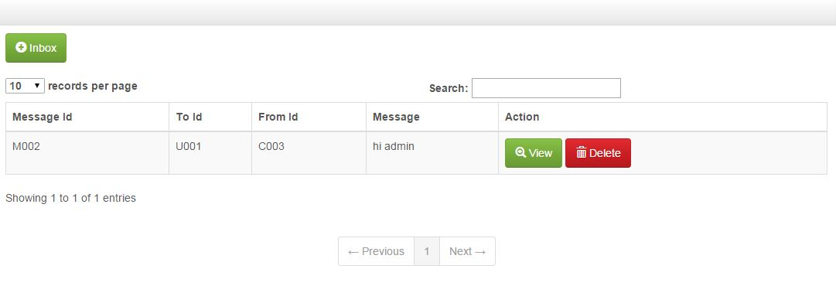

Figure B.25 sent Message Interface

The add salary link has a form to enter a basic salary of the company staffs. In the form there is an option list of the staff designation. After selecting the staff, enter salary details and submit, then the system check whether it is already added or not. If already added to the system, then the system provides an error message, if not the system provide successful message. It is shown in the following Figure Add salary interface

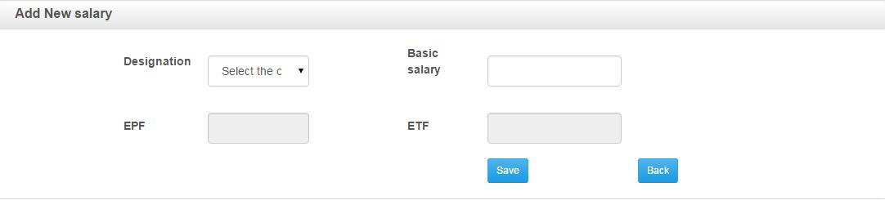

Figure B.26 Add Salary Interface

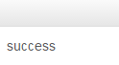

Figure B.27 Success Message

To add feedback, customer can add his own views regarding the products. It can only be viewed by admin. It is shown in Figure Feedback Interface

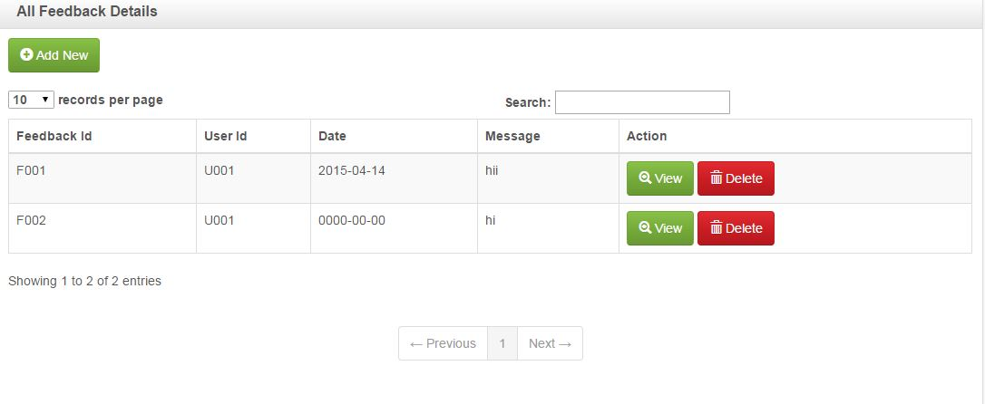

Figure B.28 Feedback Interface

Admin can able to add products and can able to check payment details. It is shown in Figure Order Interface

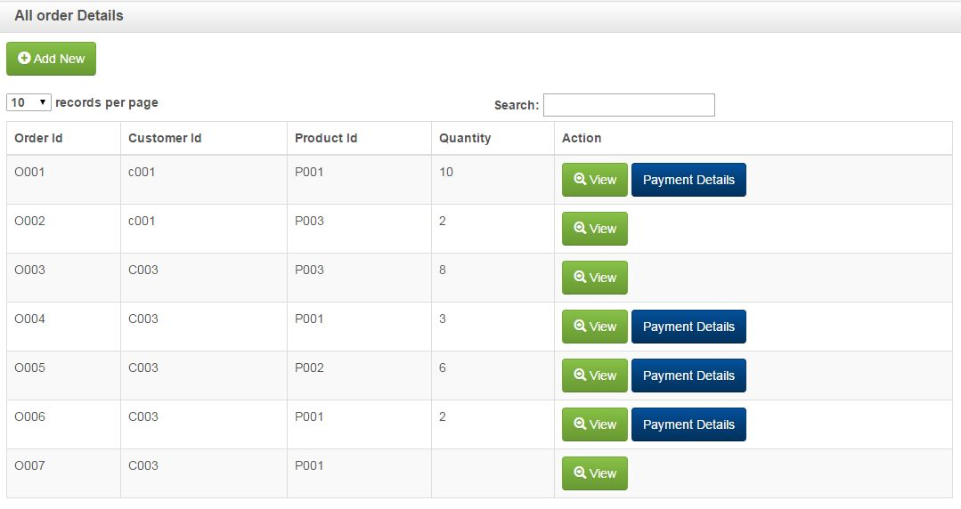

Figure B.29 Order Interface

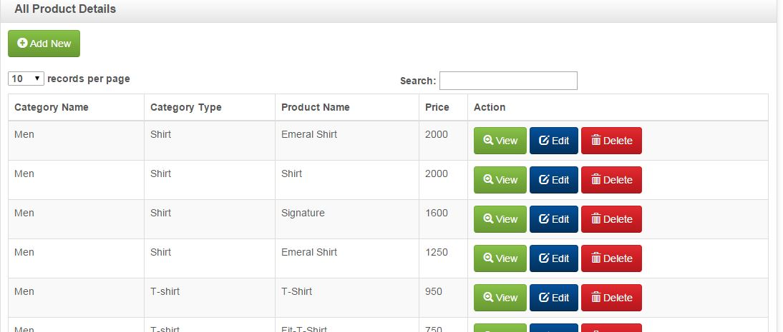

Figure B.30 Product Interface

**Manager Interface**

The manager menu page has some access link such as Home, Customer, Staff, Branch, Product, Category, Inventory, Order, Purchase, Supply, Delivery, and Monthly salary, Feedback, Message and Logout. The customer link provides a form to create a new customer under that login branch manager area. The delivery link provides a form to create a new deliver under that login branch manager area.



Figure B.31 Manager Interface

Add new order link is provides a form to create a new order under that branch. After inputting the details and submit the details, then system will provide a successful message.

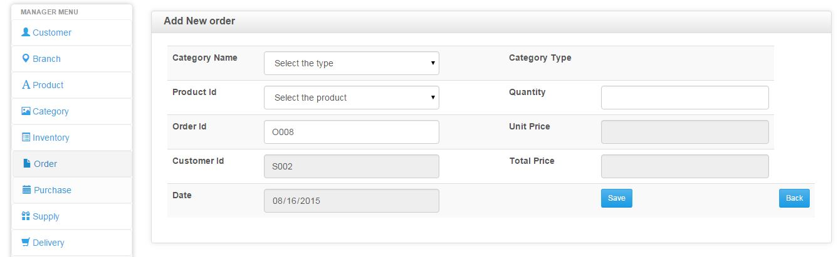

Figure B.32 Add New orders



Figure B.33 Add Delivery Interface

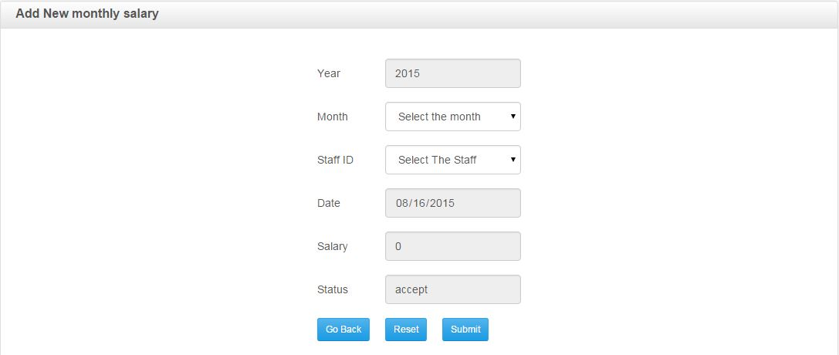

Figure B.34 Add Monthly Salary Interface

**Staff Interface**

The staff interface has some links such as Home, Customer, Product, Category, Inventory, Order, Delivery, Monthly salary, Message, Feedback and Logout. The home link is navigating the screen to main screen. The order link provides a make order form for making order through online. The product link provides a form to view any new product to sale from our system. The delivery link provides a form to add any new delivery to our system. The monthly salary link provides form to view salary for different types of user.

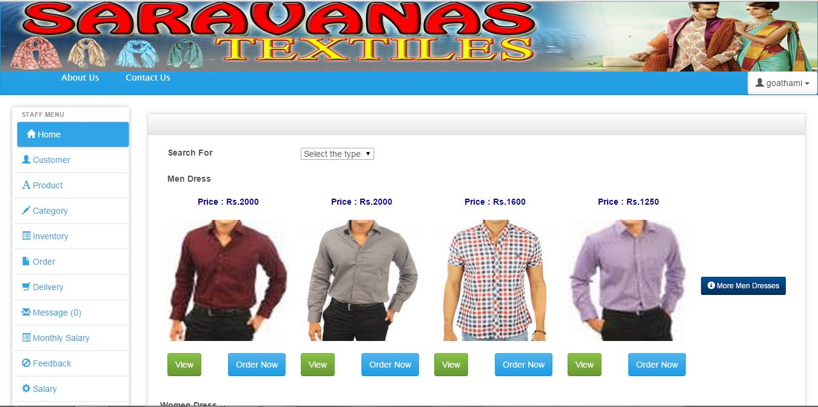

Figure B.35 staff Interface

The delivery link provides a form to add any new delivery to our system.

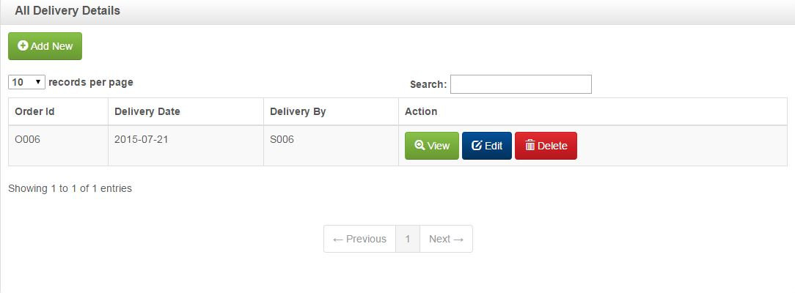

Figure B.36 Delivery Interface

The monthly salary link provides form to view salary for different types of user.

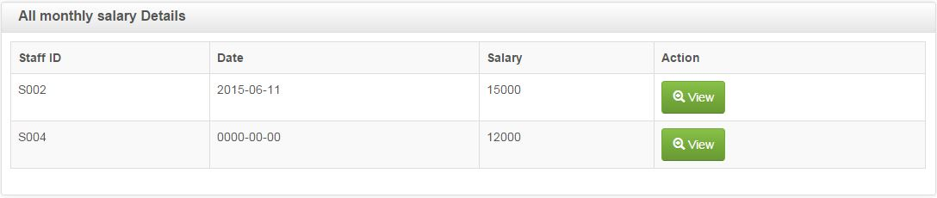

Figure B.37 Monthly Salary Interface

**Customer Interface**

The customer menu page has some link such as Home, Profile, Product, Category, Order, Message, Feedback and Logout.



Figure B.38 Customer Interface

The go home link is navigating the interface to main screen. The product link shows the product details. The order link provides a make order form for make order through online. The profile link provides the details about the login customer details. The message link provides the message details of that login customer.

The make order link provides a form to make an order through our system. There is an option list which has product category where customer has to select a product name from home page, then you type the quantity in the text box, the system will automatically calculate the quantity price and display it in textbox. After submitting the order, system automatically sends a message to that customer’s telephone number as “you got an order”. And also send order code to that particular customer’s telephone number. After deliver the product, the customer gave that code to deliver person. All these formalities are for verification.



Figure B.39 Make Order Interface



Figure B.40 Register new customer

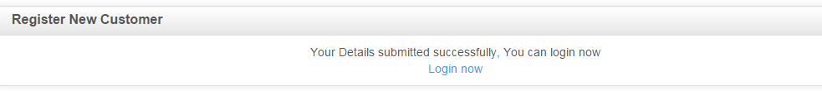

Figure B.41 Success of Registration

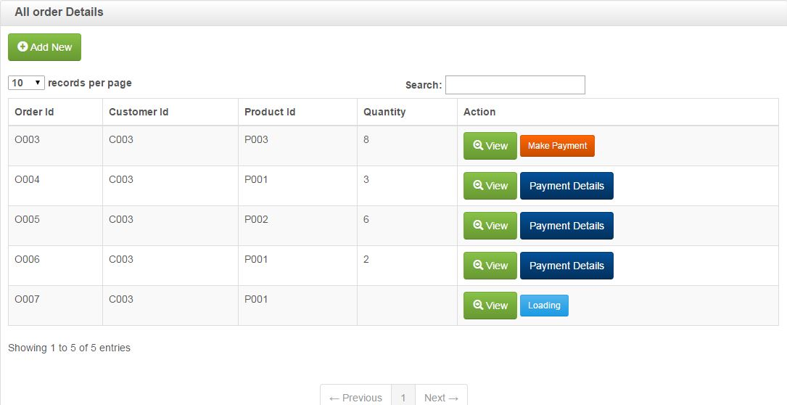

Figure B.42 Customer Page Order Interface

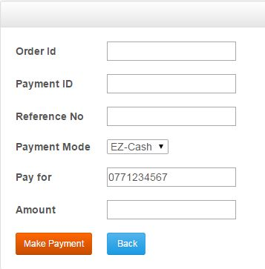

Figure B.43 Make Payment

In this system, when user enters any details in a form user must enter all the required details, without entering the details, the system will not allow user to do anything. In fields like customer name, manager name and staff name, in those text boxes user can input the text only. On the other hand like quantity, price, and telephone number fields’ user can input number only. In telephone number field, the system checks whether it’s a hand phone number format or not. In password field you must enter more than six characters.

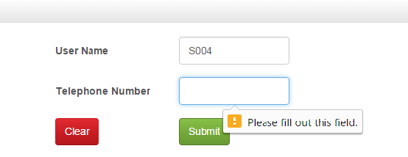

Figure B.44 Error for not Fill



Figure B.45 Error for not E-Mail



Figure B.46 Wrong Format of Hand Phone Number

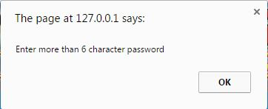

Figure B.47 Password More Than six Characters

**Cashier Interface**

The cashier menu page has some link such as Home, Customer, Product, Category, Order, Monthly salary, Feedback, Message and Logout.

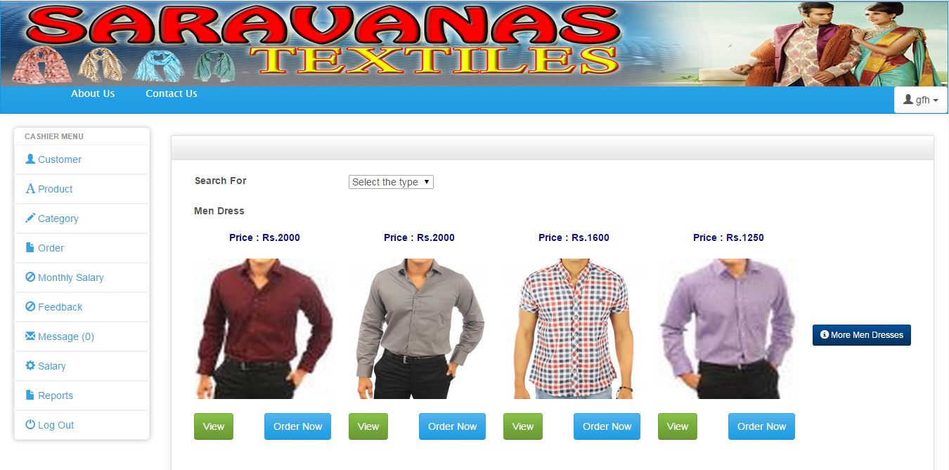

Figure B.48 Cashier Interface

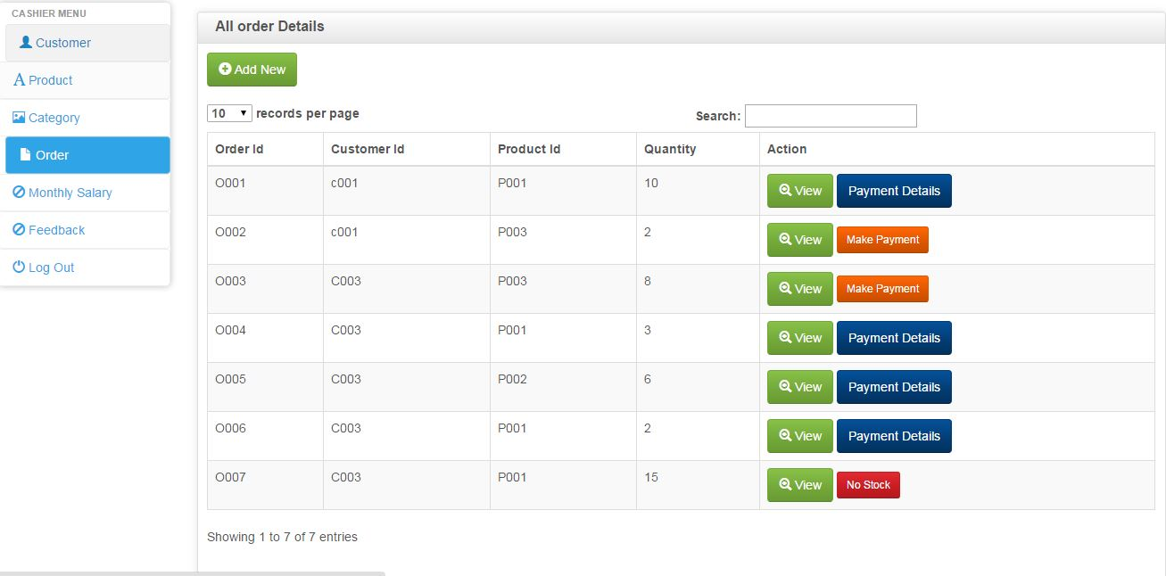

Figure B.49 Cashier Page Order Interface

## **APPENDIX C – Management Reports**

The system allows the administration, manager, staff and cashier to generate reports with their appropriate power. They can generate these reports customer details, staff details report, payment report.

**The Customer details report**

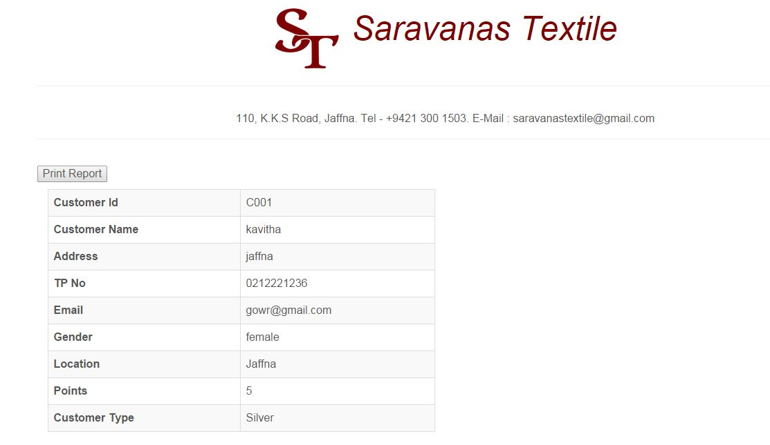

Figure C.1 Customer Details Report

**The payment report**



Figure C.2 Payment Report

**Appendix D – Test Results**

|  |
| --- |
|  |

|  |  |  |
| --- | --- | --- |
| Test case | Screen short | Result |
| When we enter wrong username or password | H:\thulashi.desi\username error.PNG | pass |
| If forget password | C:\Users\Thulasi\Desktop\thulashi.desi\Screenshot\phonecode.JPG | pass |
| In change password, new password and retype new password are different | C:\Users\Thulasi\Desktop\screen shot\missmatch newpwd.PNG | pass |
| In change password, wrong current password | C:\Users\Thulasi\Desktop\screen shot\wrong current pwd.PNG | pass |
| Enter wrong format of telephone number | C:\Users\Thulasi\Desktop\thulashi.desi\Screenshot\wrong 10 digit.JPG | pass |
| Enter wrong format of E-Mail | C:\Users\Thulasi\Desktop\thulashi.desi\Screenshot\wrong email.png | pass |
| Enter wrong password character | C:\Users\Thulasi\Desktop\thulashi.desi\Screenshot\pwd.JPG | pass |
| Automatically show the price when we select product | C:\Users\Thulasi\Desktop\screen shot\automatic unit.PNG | pass |
| Automatically calculate the quantity, tax and total price | C:\Users\Thulasi\Desktop\screen shot\calculate.PNG | pass |
| The date picker | H:\DATEPICKER.png | pass |
| The drop down box shown | C:\Users\Thulasi\Desktop\thulashi.desi\sdfdrhy.png | pass |
| Enter wrong URL | C:\Users\Thulasi\Desktop\thulashi.desi\notfound.PNG | pass |
| Display print button in report | C:\Users\Thulasi\Desktop\thu\printreport.PNG | pass |

|  |
| --- |
|  |

# GLOSSARY

* **Apache** – Open source web server.
* **PHP** – Hypertext Pre-Processer, it is one of the famous server side scripting languages.
* **CSS** – Cascading Style Sheet described how the structured element must be rendered on screen or on media.
* **JavaScript** – it is one of the Client-side scripting languages.
* **Database** – The backend storage of system.
* **SDLC** – Software Development Life Cycle is a structure imposed on the development of a software product.
* **OO** – Object Oriented, is an approach to designing modular, reusable software systems.
* **UML** – Unified Modeling Language, is a graphical language for visualizing, specifying, constructing and documenting the artifacts of a software-intensive system.
* **WWW** – World Wide Web.
* **Web browser** – is software to access the web.
* **GUI** – Graphical User Interface, utilized to support to user to interaction with system.